**`**

**Blockchain-Based Vehicle Registration and Ownership Management System**

Troyrangers

|  |  |
| --- | --- |
| Dissanayake D.M.B.M. | 204047J |
| Herath P.A.U.D. | 204074M |
| Jayathilaka P.H.P. | 204087F |
| Pathirana S.P.S.N. | 204150T |
| Rathnayaka A.M.D.B. | 204179N |

Faculty of Information Technology

University of Moratuwa

June 2023

**Blockchain-Based Vehicle Registration and Ownership Management System**

Troyrangers

|  |  |
| --- | --- |
| Dissanayake D.M.B.M. | 204047J |
| Herath P.A.U.D. | 204074M |
| Jayathilaka P.H.P. | 204087F |
| Pathirana S.P.S.N. | 204150T |
| Rathnayaka A.M.D.B. | 204179N |

Dissertation submitted to the Faculty of Information Technology, University of Moratuwa, Sri Lanka for the partial fulfillment of the requirements of the Honors Degree of Bachelor of Science in Information Technology.

**June 2023**

**Declaration**

We declare that this thesis is our own work and has not been submitted in any form for another degree or diploma at any university or other institution of tertiary education. Information derived from the published or unpublished work of others has been acknowledged in the text and a list of references is given.

|  |  |
| --- | --- |
| Name of Student (s) | Signature of Student (s) |
| Dissanayake D.M.B.M. |  |
| Herath P.A.U.D. |  |
| Jayathilaka P.H.P. |  |
| Pathirana S.P.S.N. |  |
| Rathnayaka A.M.D.B. |  |

Date: 2023.06.09

Supervised by

Name of Supervisor(s) Signature of Supervisor(s)

Date:

**Dedication**

I dedicate this project to Crede Technologies company, the Dean of the Faculty of Information Technology, our academic supervisor, our Industrial mentor, and our lecturers. We also dedicate this work to our family members.

Thank you. Our love for you all can never be quantified.

**Acknowledgements**

We would like to express our deepest gratitude and appreciation to all those who have contributed to the successful completion of this project. First and foremost, We are immensely grateful to our supervisor, Dr.A.L.A.R.R.Thanuja, and our industrial mentor, Mr. Anura Bandara for their guidance, expertise, and unwavering support throughout this journey. We would also like to extend my heartfelt thanks to the members of our project team, for their collaborative efforts, insightful discussions, and contributions that have enriched this project. We are indebted to my friends and family who have stood by our side and provided unwavering encouragement throughout this endeavor. Their belief in our abilities and their continuous support have been a constant source of inspiration and motivation. Lastly, we would like to express our sincere appreciation to all the participants and respondents who generously gave their time and insights, enabling the collection of valuable data for this study. Their contribution is integral to the success of this research.

**Abstract**

There may be several security issues when transferring a vehicle from one person to another or registering a vehicle for the first time. However, many firms continue to utilize slower, riskier centralized management solutions. The existing solution, Vehicle Registration and Information Management using Blockchain-Based Distributed Ledger from Bangladesh Perspective ensures that the process will be faster and more transparent without the direct involvement of a third party, the system while addressing the problems in the traditional paper-based management method. This system is limited to a concept and there is no actual implementation. Therefore, this paper introduces a vehicle registration and ownership management system based on blockchain technology to overcome this issue. The system has the ability to track vehicle ownership and transfer, store, and verify important documents such as titles and registration certificates. In this system, a person can identify using a self-sovereign identity and vehicles are represented as non-fungible tokens. Furthermore, the system can verify self-sovereign identity and store it in the mobile wallet. These capabilities have the potential to streamline the process of buying and selling vehicles and reduce the risk of fraud or errors in the vehicle ownership process. The system provides a marketplace that can be used to sell and buy vehicles. When buying a vehicle, the ownership is transparently transferred through the marketplace and cannot change unnecessarily. This paper shows that the application of a blockchain-based vehicle registration and ownership management system would be able to ensure the process of vehicle registration and transfer can be done in a secure manner.

Keywords: Blockchain-based, vehicle registration and ownership management, self-sovereign identity, non-fungible token.

**Table of Content**

Chapter 1 Introduction 1

1.1 Introduction 1

1.2 Background Motivation 2

1.3 Major Issue – Mutability 3

1.4 Aim and Objectives 3

1.5 Summary 3

Chapter 2 Blockchain-Based Vehicle Registration and Ownership Management Literature Review 4

2.1 Introduction 4

2.2 Vehicle Registration and Information Management using Blockchain-Based Distributed Ledger from Bangladesh Perspective 4

2.3 Sandbox 5

2.4 OpenSea 5

2.5 Summary 6

Chapter 3 Adapted Technologies 7

3.1 Introduction 7

3.2 Web2 7

3.2.1 ReactJS 7

3.2.2 React Native 8

3.2.3 NextJS 8

3.2.4 Django 9

3.2.5 PostgreSQL 9

3.3 Web3 9

3.3.1 Blockchain 10

3.3.2 Aries Cloud Agent - Python 11

3.3.3 MetaMask Wallet 12

3.4 Docker 13

3.4.1 Docker Compose 13

3.5 Summary 13

Chapter 4 Our Approach 14

4.1 Introduction 14

4.2 Blockchain-Based Vehicle Registration and Ownership Management System 14

4.3 Users, Inputs, Outputs of the System 15

4.4 Systems Working Behavior 16

4.5 Software Process Model 18

4.6 Summary 18

Chapter 5 Analysis and Design 19

5.1 Introduction 19

5.2 Analysis 19

5.3 Design 19

5.3.1 Use case Diagram 19

5.3.2 Activity Diagram 20

5.3.3 Class Diagram 27

5.3.4 Sequence Diagram 27

5.3.5 ER Diagram 34

5.4 Summary 34

Chapter 6 Implementation 35

6.1 Introduction 35

6.2 SSI Issuer 35

6.3 SSI Verifier 35

6.4 Mobile SSI Wallet 35

6.5 NFT Minter 35

6.6 NFT marketplace 36

6.7 Implementation 36

6.8 Summary 43

Chapter 7 Evaluation 44

7.1 Introduction 44

7.2 Evaluation and Testing 44

7.3 How Our Solution Differs from Other Solutions 44

7.4 Further Development 45

7.5 Summary 45

7.5.1 NFT Marketplace System 45

7.5.2 SSI Issuer 46

7.5.3 SSI Verifier 46

7.5.4 SSI Wallet 47

7.5.5 NFT Minter 47

Chapter 8 Conclusion and Further Work 49

Chapter 9 References 50

Appendix A - Individual Contribution 53

Appendix B 58

Appendix C – Plan of Action 61

Appendix D – User Stories 62

Appendix E – SRS 63

**List of Figures**

[Figure 3‑1 Overview of the Architecture of the Aries Cloud Agent - Python 12](https://uniofmora.sharepoint.com/teams/Level2SoftwareProject/Shared%20Documents/General/Interim%20Report_final.docx#_Toc137210841)

Figure 4‑1 User, Input, Output Diagram 16

[Figure 5‑1 Use case Diagram 20](https://uniofmora.sharepoint.com/teams/Level2SoftwareProject/Shared%20Documents/General/Interim%20Report_final.docx#_Toc137210843)

Figure 5‑2 Activity Diagram of Issuing SSI process 21

[Figure 5‑3 Activity Diagram Verifying SSI Process 22](https://uniofmora.sharepoint.com/teams/Level2SoftwareProject/Shared%20Documents/General/Interim%20Report_final.docx#_Toc137210845)

Figure 5‑4 Activity Diagram saving newly created SSI 23

Figure 5‑5 Minting NFT for Vehicle 24

[Figure 5‑6 Activity Diagram NFT Market Place to sell vehicle 25](https://uniofmora.sharepoint.com/teams/Level2SoftwareProject/Shared%20Documents/General/Interim%20Report_final.docx#_Toc137210848)

Figure 5‑7 Activity Diagram NFT Market Place to buy vehicle. 26

Figure 5‑8 Class Diagram 27

Figure 5‑9 Sequence Diagram SSI Issuer 28

Figure 5‑10 Sequence Diagram SSI Verifier (Web UI) 29

Figure 5‑11 Sequence Diagram SSI Verifier (via API) 30

Figure 5‑12 Sequence Diagram Mobile SSI Wallet 31

Figure 5‑13 Sequence Diagram NFT Minter 32

[Figure 5‑14 Sequence Diagram NFT Market Place (Login with SSI) 32](https://uniofmora.sharepoint.com/teams/Level2SoftwareProject/Shared%20Documents/General/Interim%20Report_final.docx#_Toc137210856)

Figure 5‑155 Sequence Diagram NFT Market Place (to sell a vehicle) 33

Figure 5‑16 ER Diagram 34

Figure 6‑1 Marketplace Home Page 36

Figure 6‑2 QR code generation 37

Figure 6‑3 SSI Login 38

Figure 6‑4 SSI Issuing Form 38

Figure 6‑5 Email Verification 39

Figure 6‑6 Verifier 39

Figure 6‑7 More Details of Vehicle 41

Figure 6‑8 Minting Officer Login Page 41

Figure 6‑9 NFT Minting Form 42

Figure 6‑10 NFT Minting Form Cont. 42

Figure 6‑11 Forgot Password Page 42

Figure 9‑1 Implementation Backend 204047J 58

Figure 9‑2 Implementation Backend 204087F 58

Figure 9‑3 Implementation Backend 204150T 59

Figure 9‑4 Implementation Backend 204179N 59

Figure 9‑5 Jira as Project Management tool 60

**List of Abbreviations**

|  |  |
| --- | --- |
| **Abbreviation** | **Meaning** |
| DeFi | Decentralized Financing |
| EIP | Ethereum Improvement Proposals |
| ERC | Ethereum Request for Comment |
| ETH | Ethereum |
| IPFS | Inter Planetary File System |
| NFT | Non-Fungible Token |
| RTA | Road Transport Authority |
| MVT | Model View Template |
| DLT | Distributed Ledger Technology |
| ACA-Py | Aries Cloud Agent Python |
| VOMS | Vehicle Registration and Ownership Management System |
| SRS | Software Requirement Specification |
| QR | Quick Response |
| HTTP | Hypertext Transfer Protocol |
| POC | Proof of Concept |

# Introduction

## Introduction

Due to the development of blockchain, centralized organizations can be replaced with a decentralized collection of assets and participants. In 2014, Ethereum, a second-generation blockchain was released and it enabled programmers to execute smart contracts on a distributed ledger. Developers and companies can design financial apps using smart contracts that leverage cryptocurrencies and other token types of things like decentralized financing (DeFi), crowdfunding, decentralized exchanges, data archiving, etc. Recent developments in distributed ledger technology have produced ideas that simplify value exchange.

Today, digital assets might be represented as tokens that existed in the blockchain network by utilizing the benefits of blockchain and considering the governance concerns, which simplifies their transmission and traceability, boosts their transparency, and strengthens their security. In the context of blockchain technology, there are two main categories of tokens: fungible tokens, where each token has an identical value, and non-fungible tokens (NFTs), which have special properties and cannot be exchanged. Non-fungible tokens are digital assets with a special ID that are kept on a blockchain. The concept of NFT was first introduced in Ethereum Improvement Proposals (EIP)-721 and then developed in EIP-1155. Beginning in early 2021, NFTs developed into one of the most popular blockchain applications that attracted attention on a global scale. They might be computer recreations of actual things.

The ownership of digital goods (such as images, music, movies, and virtual creations) that can be traded is documented in blockchain smart contracts. As one of the first NFTs on Ethereum, CryptoPunks has created approximately 10,000 collectible punks and contributed to the growth of the ERC - 721 Standard [1]. In Blockchain Based Vehicle Registration and Ownership Management System, an innovative approach is taken to represent vehicles as digital assets through the creation of Non-Fungible Tokens (NFTs). The system utilizes the concept of minting NFTs, which involves generating unique digital tokens that serve as a digital representation of a specific vehicle.

## Background Motivation

Digitizing nonreal things has been tested until now. But digitizing real-world things has not yet. This project is mainly focusing on changing the ownership of a vehicle online. That means this system will be used to digitize a real-world thing like a vehicle. This ownership transfer of vehicles cannot be done transparently and securely using a centralized database. A centralized database is essentially a database type that is kept, located, and maintained exclusively in a single place [2]. But to address this problem using blockchain technology gives more additional features. Blockchain is a decentralized, immutable database that makes it easier to track assets and record transactions in a corporate network [3].

A centralized database and a blockchain have differences according to their architecture, immutability, data handling, and transparency. Due to the immutability, transparency, and security of these blockchains, it is better to use blockchain technology to address our problem. Because transferring vehicle ownership has to be more secure [4]. If anyone needs to change data in a blockchain that hacker has to change more than fifty percent of that blockchain nodes, and it is impractical to do such a thing. That’s why blockchains come in handy for secure transactions like changing vehicle ownership. Nowadays, NFT (Non-Fungible Tokens) is very popular among investors due to the digital value given to intangible things. One of the major reasons which resulted in this popularity is the blockchain technology that is used behind these systems. NFTs, or non-fungible tokens, are blockchain-based tokens that individually represent a special asset like a work of art, a piece of digital material, or other media [5]. Nowadays although all the systems are computerized in many fields there can happen, changing data without permission. It is a huge problem today.

Therefore, the reference company “Crede Technologies” has come up with a great idea to allow digital information to be recorded and distributed, but not edited. The company aims to do this process related to the vehicle ownership field. Therefore, Blockchain Technology is used to develop this project as the intention of the company. Nowadays in Sri Lanka, still the vehicle registering and transferring process is done through physical documents and computerized somewhat far. But it will be a great investment if we can introduce this system to Sri Lanka.

## Major Issue – Mutability

The word "mutability" refers to the attribute of changeability [6]. Ownership of a vehicle must not be changed by others unnecessarily. But when using a centralized database unauthorized people can change data and we can’t track those changes. Therefore, this is a huge security burden for this kind of high transparency needed system.

## Aim and Objectives

**Aim:** The aim of project is to develop a system for registering and transferring vehicle ownership from one person to another in a secure manner with the use of Blockchain Technology.

**Objectives:**

* To study the problem of registering and transferring vehicle ownership from one person to another through documentation.
* To facilitate digitizing the system of registering and transferring vehicle ownership from one person to another.
* To create the ability to generate a digital id for verifying person and vehicle identity.
* To design the appropriate system including all user requirements.
* To develop a system for solving the problem.
* To evaluate the proposed solution.
* To prepare final documentation.

## Summary

The rest of the paper is organized as follows. Section 2 reviews the related literature. Section 3 describes the methodology used while Section 4 discusses our approach and the results obtained. Analysis and design discussed in Section 5. Section 6 describes implementation of the system and section 7 discusses evaluation and testing and further development of system.

# Blockchain-Based Vehicle Registration and Ownership Management Literature Review

## Introduction

In the previous chapter, there has been discussed an introduction about the project and what is the reason to build this project and what are the aim and objectives related to this project. This chapter mainly focuses on the projects, and applications which are solutions to address the problem that discussed in this paper. Even though all these existing projects mainly focus on creating NFTs, they are not creating NFTs for physical assets. Blockchain technology has found implementation in various real-world applications, revolutionizing industries across the globe. Some notable examples of blockchain-based solutions that have been successfully implemented are included following.

## Vehicle Registration and Information Management using Blockchain-Based Distributed Ledger from Bangladesh Perspective

In Bangladesh, motor vehicles should be registered in order to establish and preserve a record of the corresponding owner, and they are controlled access by the Road Transport Authority (RTA). Typically, there are several RTA locations located around the country, and the government offers services for vehicle registration by having the owner complete a standard form with the necessary identification details. The data is utilized for changing ownership, authenticating vehicles, and verifying ownership.

In contrast, as part of the existing motor vehicle registration procedure, the Bangladesh Road Transport Authority (BRTA) keeps all the data associated with a motor vehicle's registration in one main database. Due to the serious security flaws in centralized systems and the increasing number of cyberattacks globally, a hacked system's single point of failure could result in a catastrophic loss. In addition, the registration process is laborious and requires manual record input, which encourages dishonest intermediaries (like brokers) to get involved. Distributed ledgers built on the blockchain have improved the security, decentralization, and transparency of the data.

In recent years, Blockchain has been widely employed for the deployment of numerous technical systems to enforce and improve through decentralization. As a result, they suggest a Blockchain-based vehicle registration and information management system that streamlines the registration procedure and keeps transparent records of ownership data. A few problems with the present or traditional paper-based approach to motor vehicle registration, including processing delays, drawn-out verification procedures, and a lack of obvious transparency, are addressed by the planned Blockchain system[7]. This is only a concept, and this project had not been implemented. Moreover, NFTs are not used in this project. However, it is our intent to take this project beyond mere theory and into the realm of practical implementation.

## Sandbox

Decentraland is one of a new generation of virtual worlds, popularly referred to as metaverses, built on the blockchain. To become a citizen, all users need is to buy LAND, a coded piece of the metaverse that translates to a 16m-by-16m plot of virtual land[8]. The assets in the metaverses are NFTs, which are digital assets on blockchains that can be used to indicate ownership of identifiable things like artwork, collectibles, and other artifacts. Blockchains enable the metaverses to have their own cryptocurrencies and, as a result, their own financial ecosystems, offering a fresh environment to test monetary ideas.

The Sandbox was first released in 2012 for iOS and Android as a game. It was rebuilt on the Ethereum blockchain in 2018. Users are able to buy LAND and build ASSET to be used in the ecosystem, creating it one of the most well-known metaverses. LANDs are NFTs that represent distinctive digital real estate (identified by coordinates), and 166,464 LANDs (408 x 408) make up the map of The Sandbox metaverse. It is possible to buy and sell each LAND either individually or as part of an estate[9].

## OpenSea

OpenSea is the largest cryptocurrency goods marketplace, specializing in NFTs and providing a wide range of crypto assets. They provide items in the following categories like virtual worlds, music, photography, sports, trading cards, collectibles, and domain names. Users can access, purchase, sell, and trade non-fungible tokens on OpenSea. The uniqueness of non-fungible tokens is that they cannot be exchanged for another item. In contrast to something like bitcoin, which is fungible and the same asset that you can exchange for another bitcoin[10]. With the help of the item minting tool from OpenSea, creators can produce their own goods on the blockchain. If users are selling products on OpenSea, users have the option of listing them for a set price, declining price, or auction[11]. When we talk about the limitations of the OpenSea, there is a Gas fee, takes time to set up a wallet and purchase ETH (Ethereum), high energy consumption, a maximum 10% royalty rate, does not take USD or Euro, difficult for artists to stand out and lack of advertising opportunities on the site[12].

The limitation of this project is that they are selling and buying virtual assets like graphics instead of real assets.

## Summary

This chapter has already outlined the preceding comparable projects. There are many limitations to those projects. In the proposed system in this paper, when designing the project, it has solved a lot of these concerns and limitations which are mentioned blockchain-based vehicle registration and ownership management system. In contrast to the blockchain-based vehicle registration and ownership management system, non-fungible tokens (NFTs) are used to represent physical assets, such as vehicles. It is stored on a blockchain, which is a distributed ledger technology that allows for the secure and transparent tracking of transactions. The rest of the paper is organized as follows. Section 3 describes the methodology used while Section 4 discusses our approach and the results obtained. Analysis and design discussed in Section 5. Section 6 describes implementation of the system and section 7 discusses evaluation and testing and further development of system.

# Adapted Technologies

## Introduction

There are many similar projects for the project discussed in this paper. But there were many differences between those projects with the proposed project from the used technologies point of view and the application’s usage point of view. That’s what was discussed in the last chapter. In this chapter, mainly focused on the technologies that are used in proposed project and give an idea about how we are referring to these technologies to address our problem. The current existing web browsers and web applications mostly support web 2.0. The proposed system is based on web 3. Therefore, it is a must to use both web 2 and web 3 technologies and frameworks. In section 3.2 and section 3.3 there is a discussion about these technologies and how these technologies are referred to separately.

## Web2

In terms of describing web 2.0, the phrase refers to online tools that let users collaborate and share with one another while also facilitating their online expression. It is only an upgraded version of the original worldwide web, distinguished particularly by the shift from static to dynamic or user-generated content as well as the expansion of social media. Rich web applications, web-oriented architecture, and social web are all mentioned in the Web 2.0 idea. Without any modifications to the technical standards, it refers to changes in the way web pages are designed and utilized by users [[13].

### ReactJS

A straightforward, feature-rich, component-based JavaScript UI library is ReactJS. Both tiny and large, complicated applications can be created with it. It was created by Facebook. ReactJS offers a basic yet reliable feature set to get a web application off of the market. React community supports React library by offering a sizable collection of pre-made components to quickly construct web applications. On top of the React library, the React community offers advanced concepts like state management, routing, etc. React has become a developer favorite and has become one of the most popular front-end frameworks [[14]. NextJS is built on top of react. Therefore, to take the NextJS support had to use ReactJS.

### React Native

A JavaScript framework called React Native is used to create native mobile applications. It was created by Facebook and is frequently used to create iOS and Android cross-platform mobile apps. Not only that but also can be used by windows, Linux, and mac OS. With React Native, mobile apps can be created of needing to maintain several codebases for each platform, developers can write code just once and reuse it for both.

The popular JavaScript library for designing user interfaces, React, is used by React Native. It enables the creation of reusable UI components, which can accelerate development and maintain a unified aesthetic across several platforms. Since React Native is open-source, developers can simply contribute to its development and advancement for free. It features a sizable and vibrant developer and user community that offers a plethora of information and assistance for creating mobile apps with React Native [[15], [16]. In SSI Mobile Wallet, there is a requirement to maintain different code bases for the same project. Therefore, a hybrid system was chosen, which presented three options for its development. Accordingly, Flutter, React Native and Xamarin were the suggestions. NFT marketplace uses React for the front end. React and React Native are a bit similar and the learning curve for React Native is less. Therefore, out of those choices, the most suitable one is React Native.

### NextJS

NextJS is a JavaScript framework for building server-rendered and statically generated web applications. It is built on top of React, a popular JavaScript library for building user interfaces, and it is designed to make it easy for developers to create fast and reliable web applications. One of the main features of NextJS is its ability to automatically optimize the performance of a web application by server rendering the initial HTML and then serving it to the client. This can help to improve the loading times of a web application, especially on slower connections or devices. NextJS also offers a range of other features that can be useful for web developers, such as automatic code splitting, built-in CSS support, and easy deployment to various cloud platforms. It is a popular choice for building web applications because it is easy to use and provides a lot of functionality outside of the box [17].

There are four major reasons to use NextJS for our project. According to that server-side rendering, automatic code splitting, static exporting, and routing can be done easily using NextJS on top of ReactJS. And not only that to work with a blockchain there are supportive modules in NextJS like web3.js, Truffle, MetaMask, and Embark.

### Django

Python-based backend server-side web application framework called Django is free and open source. It uses MVT design principles (MVT stands for Model View Template). In the current market, Django is really demanding because of its quick development capability. The development of any form of application requires less time [[18].

When developing the SSI Issuer and SSI Verifier, Django was used as the backend framework. Therefore, it is possible to handle a heavy request load. And this framework is very supportive and comfortable for rapid development. Django is a stable framework that has a big community.

### PostgreSQL

PostgreSQL is a powerful, open-source object-relational database system with a strong reputation for reliability, feature robustness, and performance. It is a popular choice for web applications, data warehousing, and more. It is designed to handle a wide range of workloads, from single machines to data warehouses or Web services with many concurrent users. It is highly customizable, allowing users to write custom functions and extensions in a variety of languages [[19]. PostgreSQL was chosen because Django has excellent support for this database.

## Web3

Web3 refers to the third generation of the World Wide Web, which emphasizes the use of decentralized technologies such as blockchain and peer-to-peer networking to enable new applications and services. Web3 technologies have the potential to enable greater decentralization, security, and privacy on the web, and to create new opportunities for innovation and collaboration. Web3 technologies have the potential to disrupt a wide range of industries, including finance, supply chain management, voting systems, and more. They also have the potential to empower individuals and communities by giving them greater control over their data and assets, and by enabling new forms of collaboration and decision-making [[20].

### Blockchain

Blockchain is a decentralized, immutable database that makes it easier to track assets and record transactions in a corporate network. An asset may be physical (such as a home, car, money, or land) or intangible (intellectual property, patents, copyrights, branding). On a blockchain network, practically anything of value may be recorded and traded, lowering risk and increasing efficiency for all parties [[21].

#### Indy Blockchain

The Hyperledger project created the open-source distributed ledger technology (DLT) platform known as Indy, which stands for "Independent Identity". It's intended to be a self-sovereign identity (SSI) solution that enables people and organizations to control their own identity data on a blockchain. Instead of being centrally managed by a single institution, identification information is maintained on a decentralized network of computers in an SSI system centered in Indianapolis. This enables people and organizations to exercise more control over and selective sharing of their own identity data. With the help of Indy, people and organizations may manage their digital identity data in a safe and private manner. It can be used for many different purposes, such as data sharing, access control, and identity verification [22].

An identity management system that is according to the standard is needed for the project. It is better than using a custom identity management system. Therefore, Indy blockchain is more suitable for proposed project. Issuing self-sovereign identity for the user and verification can be done by this blockchain.

#### Polygon Blockchain

To address Ethereum's scalability problems, a stack of protocols called Polygon was created. By managing transactions on a different Ethereum-compatible blockchain, the Polygon network resolves the network's issues. Transactions are then returned by Polygon for post-processing on the main Ethereum network. This strategy lessens the stress on Ethereum's network. Through this, Polygon can accelerate transactions and bring down transaction costs to just a penny. In other words, Polygon, formerly Matic network, offers a simple foundation for new and current blockchain projects to develop on Ethereum without scalability difficulties. Users that use Polygon never have to be concerned about network congestion when interacting with any decentralized application (DApp) [[23].

There are two choices to write smart contract/ chain codes. Those are hypogene fabric and Ethereum 2.0. The hypogene fabric is less supportive compared to Ethereum. Therefore, Ethereum was chosen. Then there are two choices between normal Ethereum and polygon blockchain. Both of these are based on Ethereum and there is no issue with technology and security. But Polygon was chosen as it is cost-effective.

#### IPFS Blockchain

Inter Planetary File System (IPFS), a peer-to-peer (P2P) hypermedia protocol, was introduced in an effort to bring about a new internet revolution. Users may store and access data including files, programs, and webpages thanks to this distributed infrastructure. The bigger goal of IPFS is to build a global computer network that ensures censorship-resistant, private, and secure connectivity [24]. In the proposed project related files have to be saved. It is not secure to save these files in the local server. Therefore, IPFS blockchain is used.

### Aries Cloud Agent - Python

Developers can easily create decentralized identity services that leverage verifiable credentials using the flexible, extensible, non-mobile Aries agent known as Aries Cloud Agent Python (ACA-Py). ACA-Py is used as an interface to a legacy system to issue verifiable credentials, an authentication service based on the presentation of verifiable credential proofs, an enterprise wallet to hold and present verifiable credentials about that enterprise, and a user interface for a person to use a wallet not stored on a mobile device [[25].

The Polygon blockchain is used to communicate with the Indy blockchain. It is very hard to use SDK of Indy blockchain as it has some bugs. Therefore, ACA-Py is used to communicate with the Indy blockchain[26] [27].

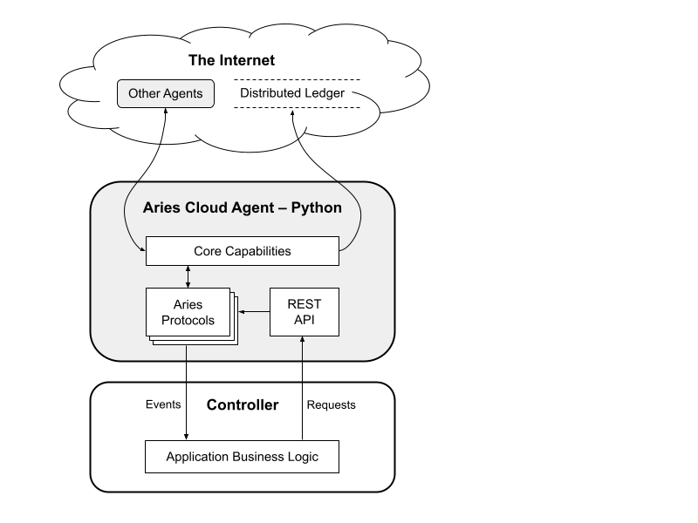

Figure ‑ Overview of the Architecture of the Aries Cloud Agent - Python

### MetaMask Wallet

Several different Ethereum-based tokens and non-fungible tokens (NFTs) are supported by the well-known cryptocurrency wallet MetaMask on supported blockchains. While seasoned cryptocurrency investors would value the wallet's speed and simplicity, novice investors might find it challenging to use. A deterrent for investors whose primary investment is Bitcoin is the wallet's lack of support for Bitcoin [[28]

A digital wallet and browser extension called MetaMask is used to communicate with the Ethereum network. This application can be used to connect with decentralized applications (dApps) created on the Ethereum platform as well as store, manage, and use users’ Ether (ETH) and other Ethereum-based assets.

With MetaMask it is possible to manage Ethereum assets and accounts, as well as sign and send transactions on the Ethereum network. As a result, Application features and services can be used without having to install them locally on computer by interacting with them in browser. Generally, MetaMask wallet is the easiest way to do the transactions with Ethereum.

## Docker

Docker is a tool designed to make it easier to create, deploy, and run applications by using containers. A container is a lightweight, stand-alone, and executable package that includes everything an application needs to run, such as code, libraries, dependencies, and runtime. Docker provides a way to create and manage containers, allowing developers to focus on writing and deploying their applications, rather than spending time on the underlying infrastructure. Docker also provides a platform for sharing and distributing containerized applications, through a registry called Docker Hub [[29] When Aries cloud python is installed on a local machine, there are so many dependency errors have to be faced. To solve these errors, Aries Cloud Python (ACA py) has been introduced officially to docker.

### Docker Compose

Docker Compose is a tool for defining and running multi-container Docker applications. It allows developers to use a YAML file to define the structure and configuration of their application's services, and then use a single command to create and start all of the services from their configuration. Overall, Docker Compose is a useful tool for developers who are working with multi-container applications, as it provides a way to define and manage the components and their dependencies in a simple and consistent manner [[30].

## Summary

In this chapter, the technologies which are used in the proposed project are already outlined and the technologies are being referred to in order to address our problem. Those are web2; ReactJS, React Native, NextJS, Django, and Blockchain; Indy, Polygon, IPFS, and Aries Cloud Agent- Python, Mets Mask Wallet, Docker, and Docker compose. In the next chapter, the proposed solution will be discussed, including the users, the activities they have done, the inputs and outputs, and how the goal is achieved. Furthermore, the software process model that was used to define and organize the activities and tasks involved in the development of the project. The discussion in the next chapter will focus on how the problem mentioned in the first chapter is addressed by using the aforementioned technologies.

# Our Approach

## Introduction

In the previous chapter, the technology adapted to this project was mentioned. In this chapter the proposed solution, who are the users of this system, what are the inputs and outputs and the way that how to achieve this goal, and the software process model that has to be used to define and organize the activities and tasks involved in the development of this project. The Vehicle Registration and Ownership Management System is an application that facilitates digitizing the system of registering and transferring vehicle ownership with the use of Blockchain technology and NFTs are used for representing the vehicles. Users who want to sell or buy vehicles in a secure manner can use this application.

## Blockchain-Based Vehicle Registration and Ownership Management System

The main intention of this project is to digitize the registration and ownership management system of vehicles. It is required to implement this system with security and transparency, as security is the most required factor in these kinds of systems. Therefore, it is not much better to use a centralized database, and therefore the best approach is to use a blockchain to store the data. The main task of our system is to convert a physical asset into a digital asset. As an example, in this vehicle registration and ownership management system, conversion of vehicle asset into a NFT (Non-Fungible Token) will take place.

When taking the legal side of the vehicle, this system must register in a government-affiliated institution. Otherwise, when selling or buying registered vehicles, the vehicle's owners must transfer legal ownership properly. It is possible to track all the vital information such as transfer date of the vehicle, and the owner after transferring the ownership of the vehicle in a super secure manner with this system. There is a special process that happened in registering the vehicle. When registering the vehicle, it is possible to mint (create) NFT with all details of the vehicle. According to that, there can be standardized photographs and all the information related to the vehicle included in the scanned copy of the vehicle registration book. And there is a vehicle marketplace to provide the facility of selling and buying vehicles. In this process, transferring ownership of the vehicle happens through the NFT. When the vehicle's lifetime is over, it is necessary to remove it from use. In that case, burn-out of the related NFT will be done. But the information related to that NFT will remain forever with that blockchain. In the current situation, it is a must to identify a person legally on the internet. But there is no proper way to show a person’s digital identity. That means a person cannot be legally identified in the internet. Because of that, first it is necessary to issue a digital verifiable ID for each and every person. Then identify the vehicle owner through this digital verifiable ID is possible and, can use this ID to login the digital marketplace.

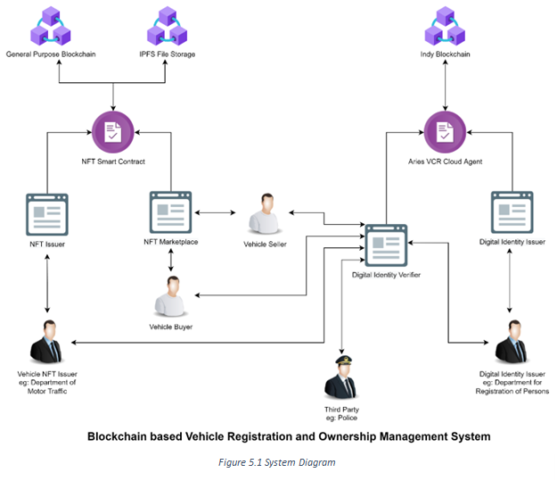

## Users, Inputs, Outputs of the System

In this system, there are six users as General user, SSI issuing officer, Seller, Buyer, Vehicle owner, and NFT minting officer. The inputs of the Vehicle Ownership Management System are SSI as login credentials, NFT requesting form, NFT selling request, payment and NFT details which are related to the buying a vehicle, SSI creating form.

General user inputs SSI as the login credentials. Then the VOMS (save the SSI. SSI issuing officer submits the SSI creating form as the input to the VOMS. The seller input the NFT selling request to the VOMS. The buyer inputs the payment and NFT details which are related to the buying process to the VOMS. The VOMS outputs the NFT details to the buyer. NFT minter submit the NFT requesting form to the VOMS. And the VOMS outputs NFT address to the NFT minting officer.

Figure ‑ User, Input, Output Diagram

## Systems Working Behavior

In this entire system there are five parts. Those parts are the SSI Issuer, SSI Verifier, NFT Minter, NFT Vehicle selling and Buying Market Place and the SSI Wallet.

First, if any person needs to sell or buy a vehicle, that person must have an SSI to log in to the vehicle buying and selling marketplace. General users should give a hard copy of the SSI est form to SSI issuing officer. Then the SSI issuing officer logs into the SSI issuer application. SSI issuing officer enters user’s details into the SSI issuer application which is included in the SSI requesting form. After validating these data SSI issuing officer submit the form. Then these details were saved in the Postgres database in the SSI Issuing. SSI issuer sends an email to that user’s email account which user provided to the SSI issuing officer. This email includes a link. When the general user clicked that link it will generate a QR code. Then the general user should scan this generated QR code through his mobile SSI wallet. After scanning that QR code, mobile SSI wallet establishes a connection between SSI issuer and mobile SSI wallet through HTTP requests. Then SSI issuer pass the credential through Indy blockchain to the mobile SSI wallet.

When a vehicle owner wants to sell a vehicle through the marketplace, he or she want to get a NFT which represent their vehicle. To do that firstly the vehicle owner should give a hard copy of NFT requesting form. Then NFT minting officer log into the NFT minter application. NFT minting officer enters vehicle’s details into the NFT minter application which is included in the NFT request form. At the same time NFT minting officer does a manual verification about provided details. As a further development, we can also add a verification with the database maintained by the government with vehicle details. After that, the NFT minting officer submits the form. The NFT is then minted in the polygon blockchain. After that, ownership of the NFT is transferred to the owner who the NFT requested within the polygon blockchain. This is the NFT minting process.

When a general user wants to buy or sell a vehicle, that person wants to go to the marketplace. After the general user went to the marketplace there is a QR code which linked with an invitation. Then the user should scan this QR code from his mobile SSI wallet. After scanning that QR code, the mobile SSI wallet establishes a connection between the NFT marketplace and the mobile SSI wallet. Then the mobile SSI wallet presents the relevant credentials from its side. Now the NFT marketplace gets that credential through the mobile SSI wallet with the help of HTTP requests. Then these credentials are verified through the SSI verifier. If this credential has been verified, then user can log into the NFT marketplace. If credentials do not verify through the SSI verifier, then we can consider that user as an invalid user.

After logging into the NFT marketplace, if the user is a seller and wants to open a request to sell his vehicle, the NFT of this vehicle is marked as sale. If the user is a buyer, then he can see all NFTs which are in the selling state with the price. After clicking the NFT that the buyer wants to buy, then the buyer can see all details such as who created the NFT, how transfer ownerships etc. These details are immutable. No one can change it. After the buyer confirmed his purchase, the transaction will happen through the MetaMask wallet to the polygon blockchain. Related payment will transfer to the smart contract. Then the ownership of the NFT will transfer to the buyer. After that, a commission will be paid to the system’s owner and the remaining amount will be transferred to the seller’s account.

## Software Process Model

This project was given by the company called “Crede Technologies”. When providing this project to our team, all the requirements were clarified correctly and clearly. Therefore, there was nothing to clarify in the software requirements. All the requirements were clear enough to give a full idea of the whole project. And there is a tight deadline to complete this project. Completing tasks one by one instead of concurrently is the approach that our team has to use. Our project development team does not consist of professionals and therefore most of the work is done as a team, instead of doing things individually. And there is a larger learning curve to follow. That is why the incremental model is not that handy to use for this project. Also, it is hard to communicate with our customers regularly. Therefore, the prototyping model is not suitable for this project. As system requirements are clear and there are no changing requirements, there is no need for an agile approach. Considering all these facts and due to the correct and clear SRS, which is provided by the company, it is better to use the waterfall model as the software process model.

## Summary

In this chapter, the proposed solution, the users, the inputs and outputs, and the process to achieve the goal were outlined. The software process model used to define and organize the activities and tasks involved in the project's development was mentioned as the "Waterfall Model". The next chapter will discuss the analysis and design of the project.

# Analysis and Design

## Introduction

In chapter 4, the description with reference to users, inputs, outputs, process, technology that implements the solution were discussed. In this chapter, the requirements of the client are gathered and started to design the system after identifying the issue. At first, UML diagrams were designed for ease of understanding the system better. After Activity, Class and Sequence diagrams were designed to further understanding.

## Analysis

Before designing the system, the functional and non-functional requirements in the system were identified as the client mentioned. The functional and non-functional requirements are mentioned in the SRS document.

## Design

In this chapter, mainly focused on the diagrams that we designed to visualize the functional and non-functional requirements. Lucid Chart is used to draw diagrams. There are several UML diagrams,

1. Use case Diagram
2. Activity Diagram
3. Class Diagram
4. Sequence Diagram
5. ER Diagram

### Use case Diagram

A use case diagram at its least difficult is a representation of a user's collaboration with the system that shows the connection between the user and the diverse use cases in which the user is included.

### 5.3.2 Activity Diagram

Figure ‑ Use case Diagram

There are several activity diagrams to demonstrate some of the major activities in the system.

* SSI Issuer
* SSI Verifier
* Mobile SSI Wallet
* NFT Minter
* NFT Marketplace

#### SSI Issuer

First, have to identify a user before he/ she enters the marketplace. So, user should get their SSI. Then user can verify their own identity to the system. For that user should be fill the SSI creation form. And it will be submitted by the authorized office. Then it goes through multiple verifications processes and finally it issues and SSI directly to the user’s wallet.

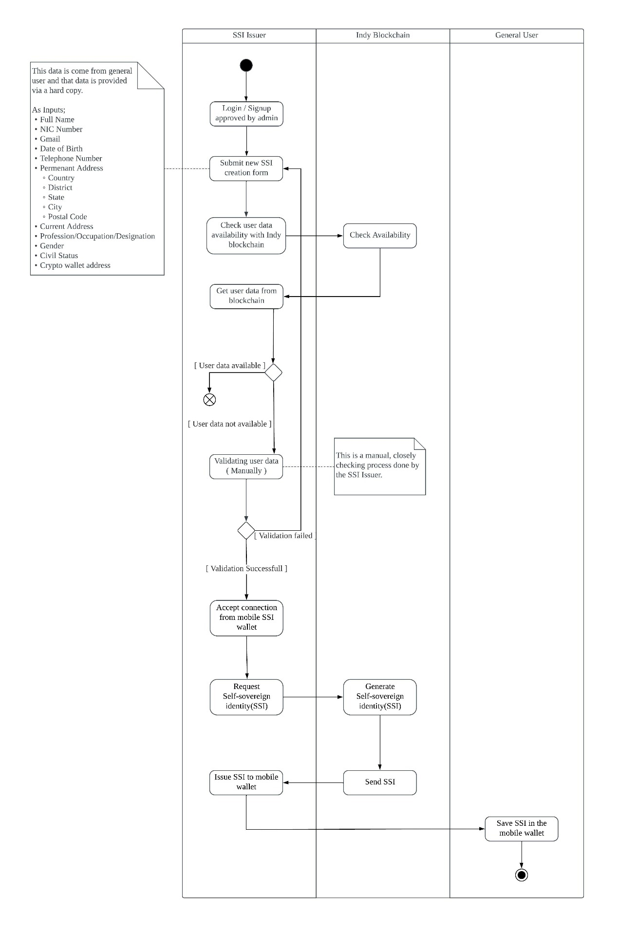

Figure ‑ Activity Diagram of Issuing SSI process

#### SSI Verifier

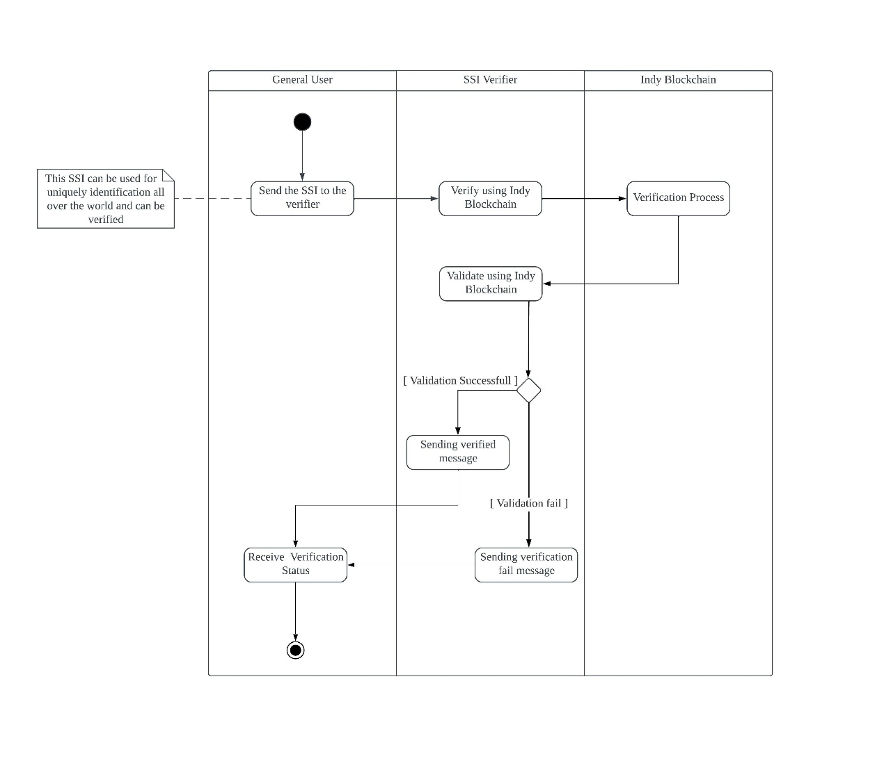

Figure ‑ Activity Diagram Verifying SSI Process

#### Mobile SSI Wallet

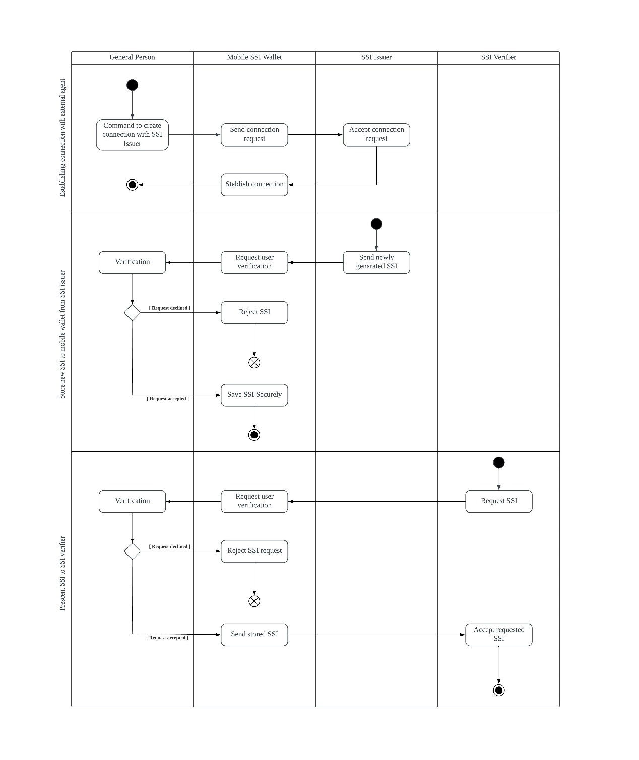

Figure ‑ Activity Diagram saving newly created SSI

#### NFT Marketplace

Figure ‑ Minting NFT for Vehicle

Figure ‑ Activity Diagram NFT Market Place to sell vehicle

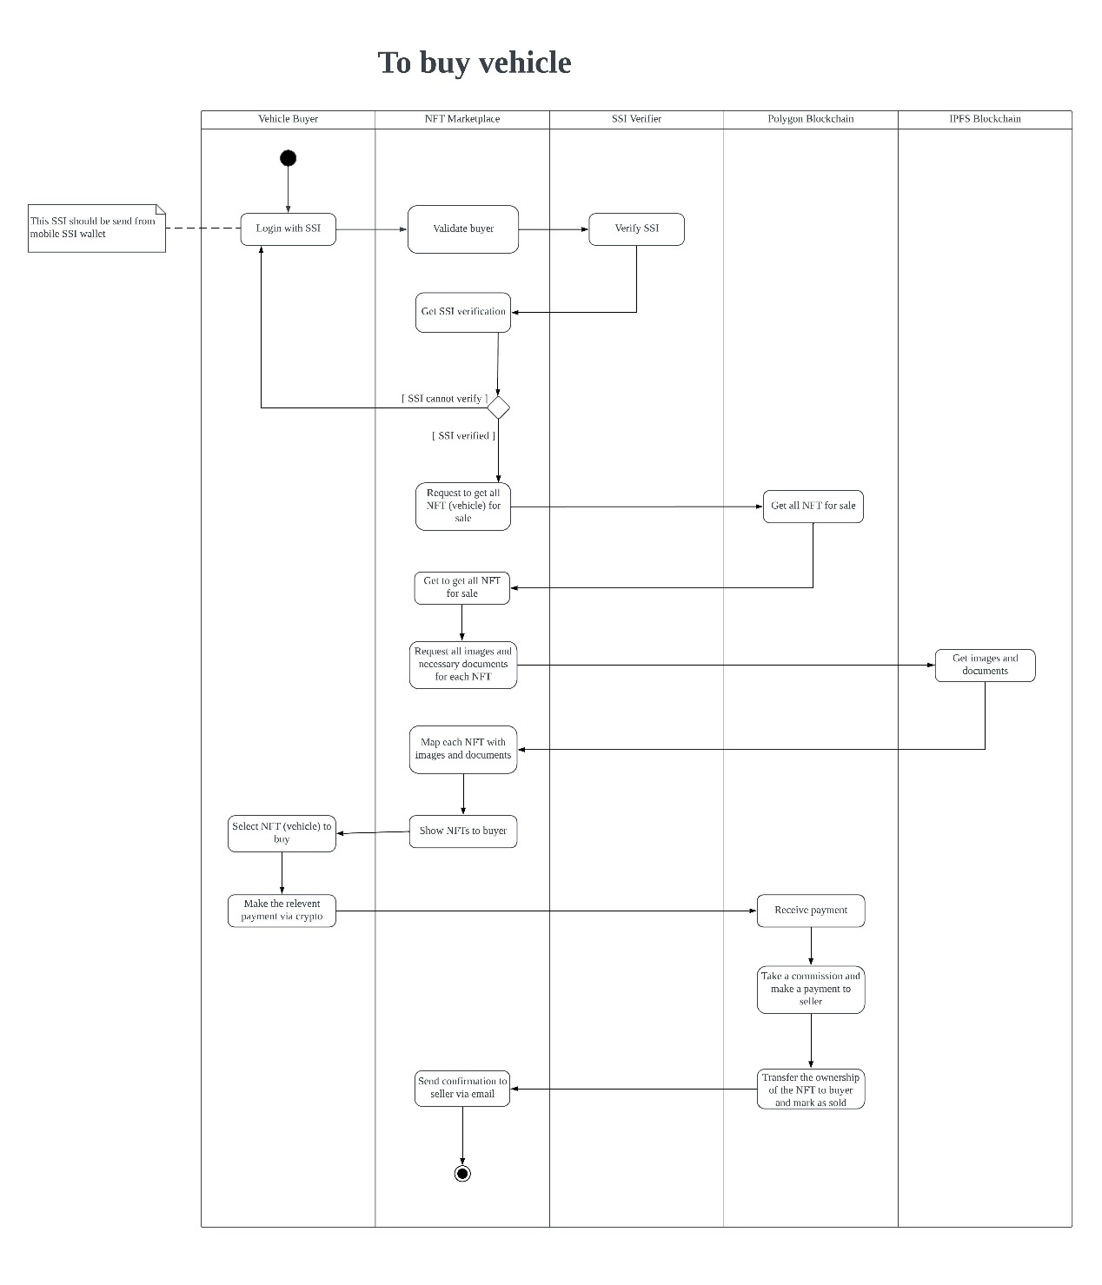

Figure ‑ Activity Diagram NFT Market Place to buy vehicle.

### Class Diagram

A class diagram is a sort of static structure diagram that portrays the structure of a system by demonstrating the system's classes, their properties, methods and the relationship among objects.

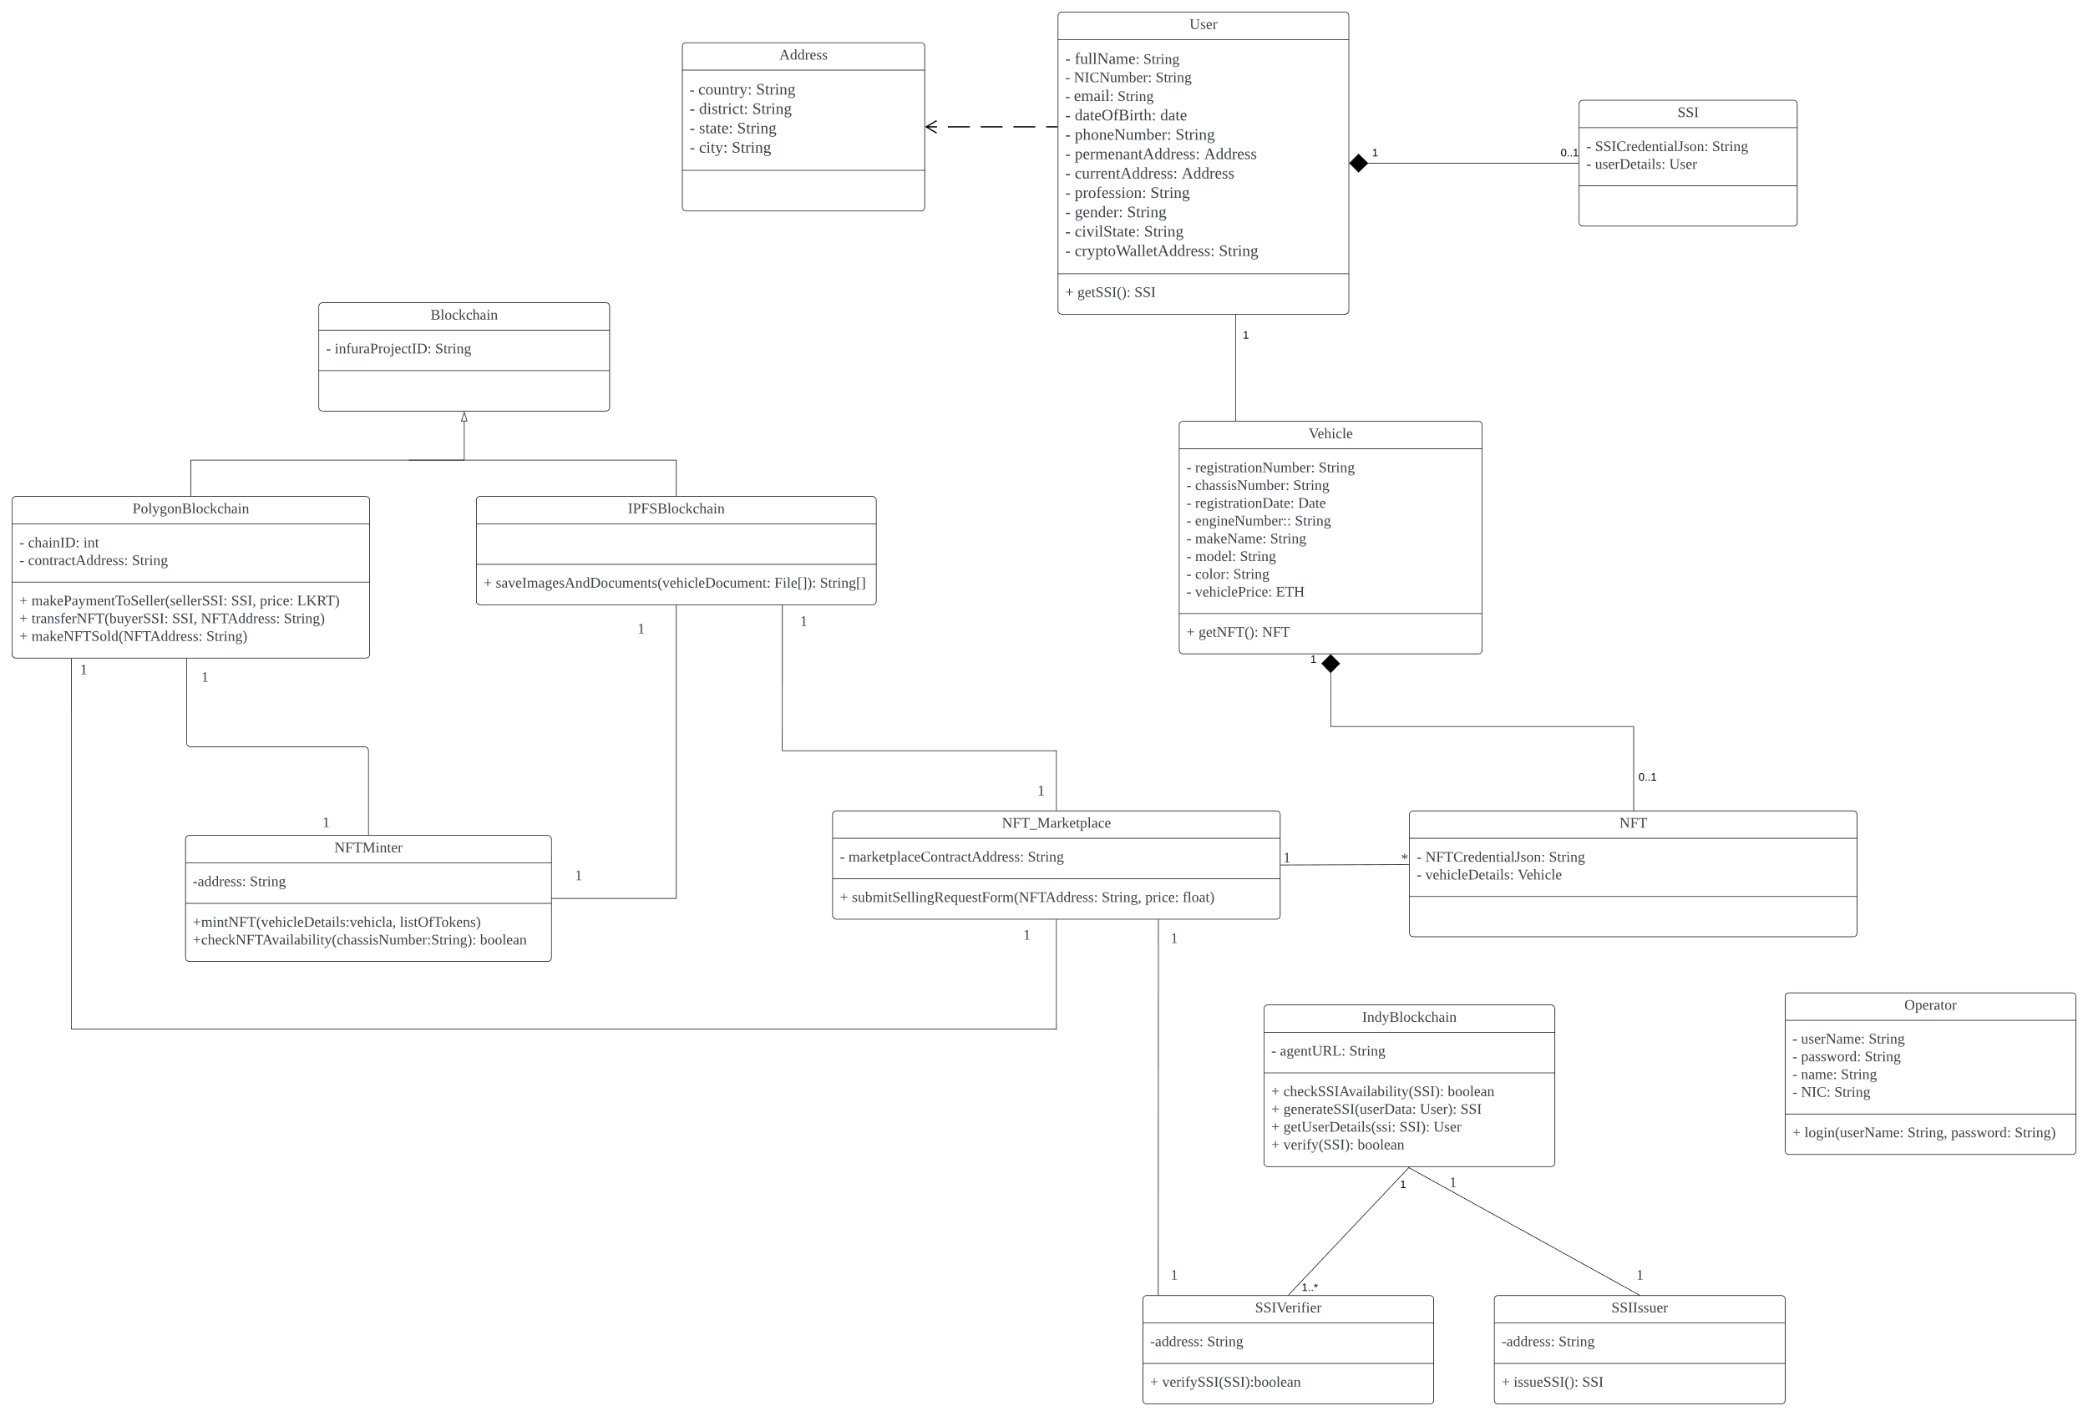

Figure ‑ Class Diagram

### Sequence Diagram

A sequence diagram shows object connections organized in time sequence. It demonstrates the objects associated with the scenario and the sequence of messages exchanged between the objects expected to complete the usefulness of the scenario. There have been designed several sequence diagrams as illustrated above.

#### Issuing SSI process

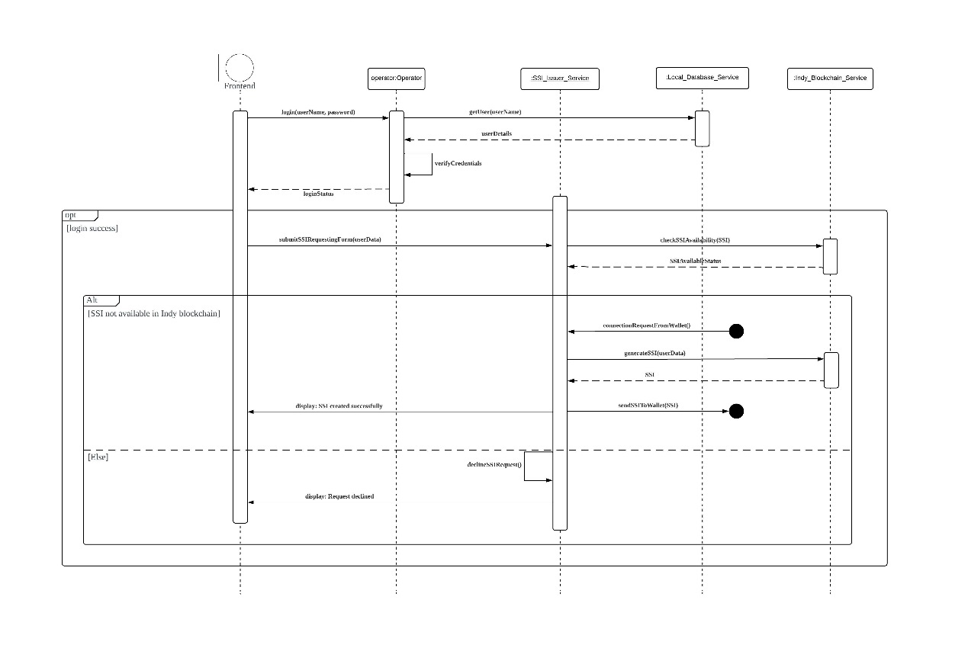

Figure ‑ Sequence Diagram SSI Issuer

#### Verifying SSI process

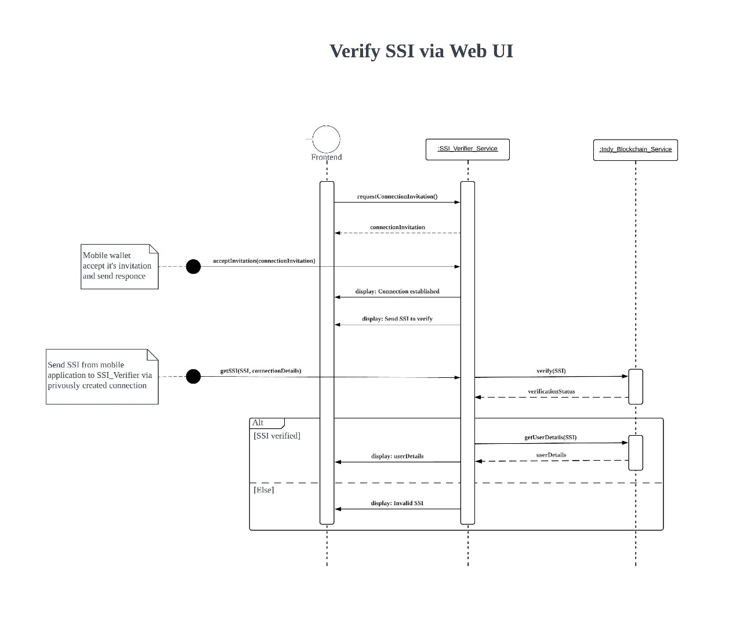

Figure ‑ Sequence Diagram SSI Verifier (Web UI)

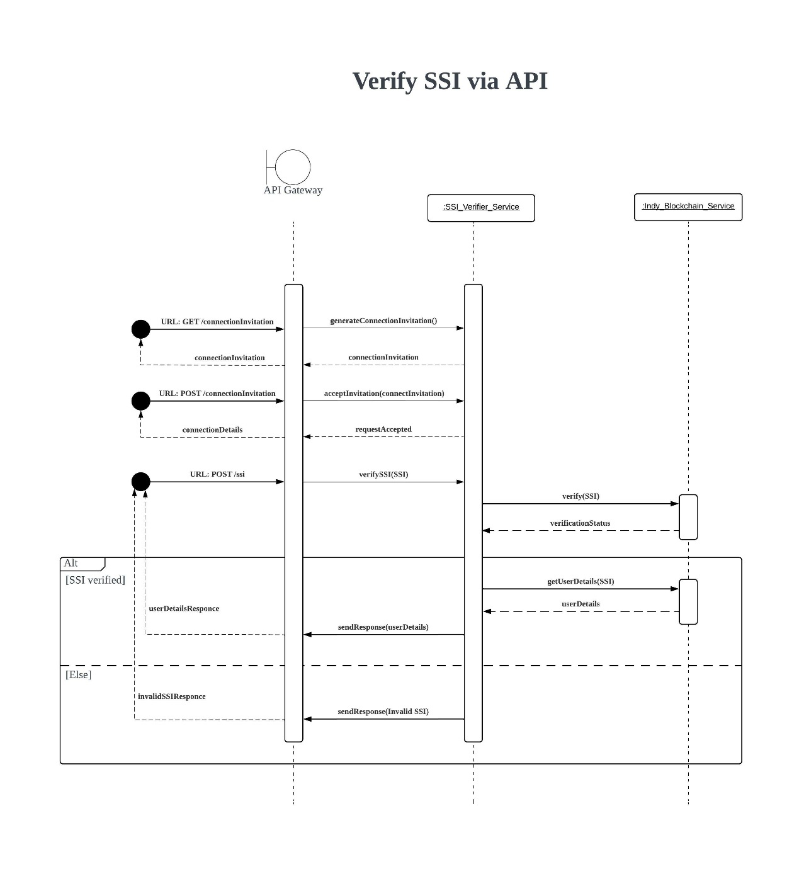

Figure ‑ Sequence Diagram SSI Verifier (via API)

#### Saving Newly Created SSI

Figure ‑ Sequence Diagram Mobile SSI Wallet

#### Minting NFT for Vehicle

Figure ‑ Sequence Diagram NFT Minter

#### Buying and Selling Vehicle in a Marketplace

Figure ‑ Sequence Diagram NFT Market Place (Login with SSI)

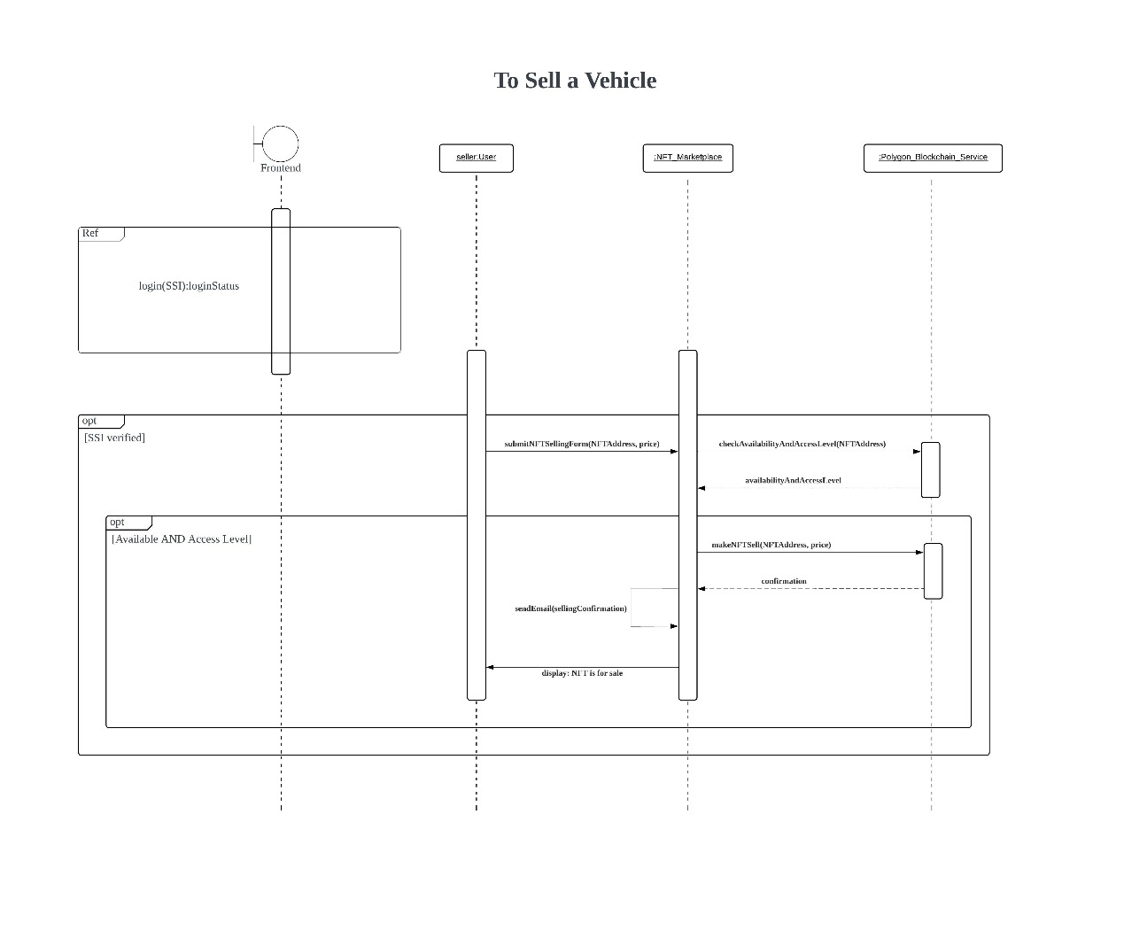

Figure ‑16 Sequence Diagram NFT Market Place (to buy a vehicle)

Figure ‑ Sequence Diagram NFT Market Place (to sell a vehicle)

### ER Diagram

**Note:** The main reason to use a database is not to save permanent data on those databases. For that purpose, blockchain are used. But there is a need for a database to maintain the usability and email verification of the system. Furthermore, want to save those data until do a proper email verification to avoid spam emails. Therefore, there is no need to save these data in the blockchain. It is a high-cost work. That is the only requirement to use a database in this system. Please find below the ER diagram corresponding to the database.

Figure ‑ ER Diagram

## Summary

Through this chapter analysis and design, the diagrams like Use case, Class, Activity and Sequence were presented and they provide the basic understanding about design and analysis of the project. The next chapter provides the strategies followed for implementing modules.

# Implementation

## Introduction

In chapter 5, outlined how the requirements of the client were gathered and started to design the system after identifying the issue. This chapter provides the strategies followed for implementing modules. In the implementing process the application is divided into five parts like SSI Issuer, SSI Verifier, Mobile SSI wallet, NFT Minter, and NFT Marketplace. The selected software process model is the waterfall model.

## SSI Issuer

In Blockchain Based Vehicle Registration and Ownership Management System, there is using a SSI- Self Sovereign Identity which is an ID to identify the vehicle owner which is a digitally verifiable ID. This ID can be used to log in and log out of the digital NFT marketplace (vehicle). The data for the SSI creation form comes from the general user and that data is provided via a form filled by the general user manually. This is a closed system that can be only accessed by the SSI issuing person.

## SSI Verifier

The SSI verifier verifies the SSI which is sent by the NFT minter, NFT marketplace and other necessary parties. It is verified by using the Indy blockchain and sending a message as response confirming the validation of the details.

## Mobile SSI Wallet

The SSI (Self-sovereign identity) which is issued for users through the SSI issuer system. This mobile application is used by normal citizens and especially the target audience is the ones who use the vehicle marketplace. When any third-party person needs to check the identity of any person, that third-party person can check that person's SSI (which is stored in this mobile application) and identify that person.

## NFT Minter

In this system, after issuing a Self-Sovereign Identity (SSI), there is a need to register their vehicle also. Nonfungible Token (NFT) is used to represent the vehicle in NFT marketplace. To do that, in the system there is minting an NFT with all details of the vehicle and transfer ownership. This is a closed system. This system is used by only authorized persons in a particular company. When a vehicle is registered for the first time the vehicle owner wants to go to that company to register his vehicle with all necessary details.

## NFT marketplace

In the system, there is a platform to sell and buy vehicles. This is an open system for any user. Anyone can access the system through their Self Sovereign Identity (SSI).

## Implementation

Images of the implemented parts are in appendix B.

Mainly there two scenarios in the login function. First one is logging into Marketplace as an unregistered user. That user’s purpose is just visiting the marketplace. They not doing buy or sell processes. The second one is for users who are going to buy or sell vehicles.

When considering the buying and selling function, there are also two main scenarios. First one is for those who have an account.

Figure ‑ Marketplace Home Page

If a user has an account, then when logging to the system, they have to verify credentials through the App. For that scenario first has to log into the system. Then the QR code is displayed to user. After scanning it can verify the user.

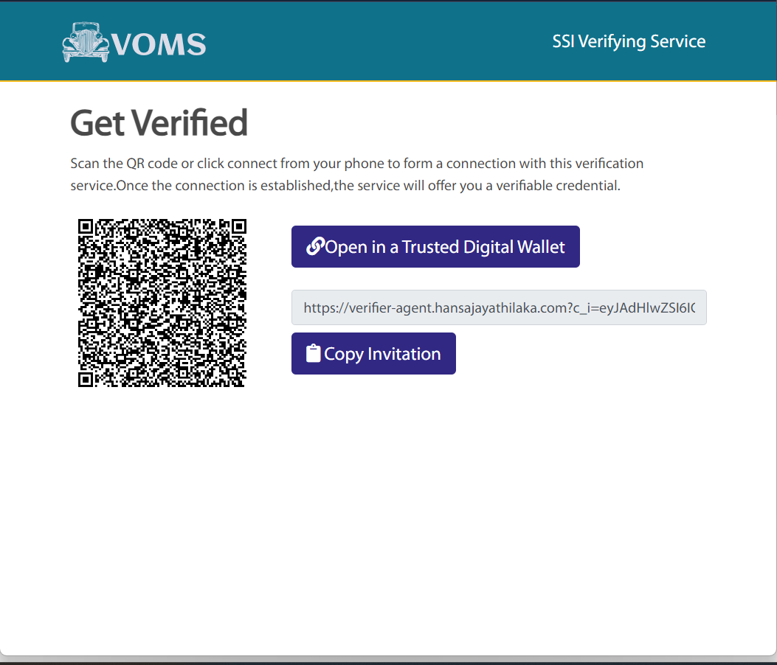

Figure ‑ QR code generation

The second scenario is for who do not have an account. They have to create a SSI to continue their buying and selling process. Firstly, SSI issuing officer logs into the system. After that the officer has to fill the SSI requesting form and submit it. Once he submits the form then an email message is sent into user’s given email address for verifying his/her email. After the verification process then the QR is generated. Then can scan the QR code and save credentials in Mobile wallet. Now can log in to system using that credential.

Figure ‑ SSI Login

Figure ‑ SSI Issuing Form

Figure ‑ Email Verification

Figure ‑ Verifier

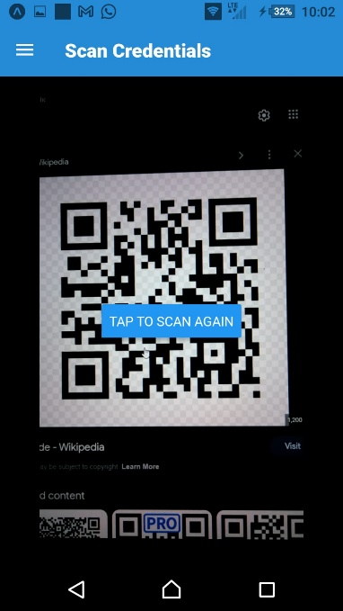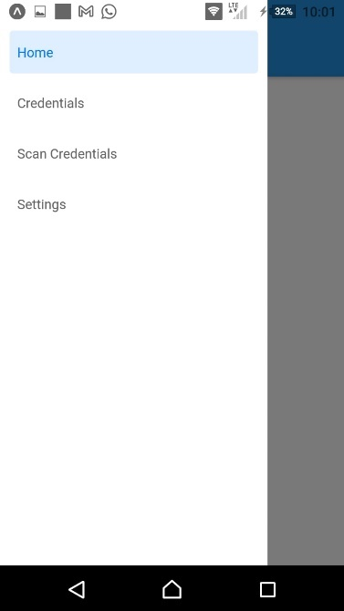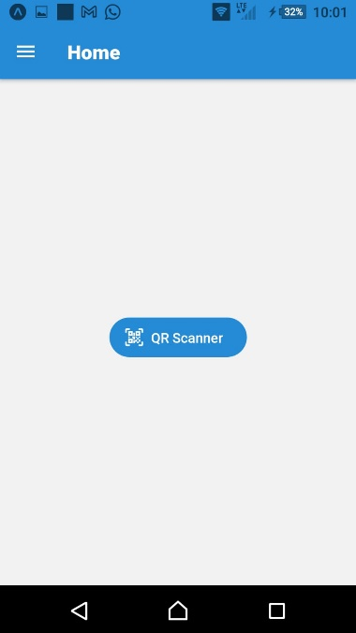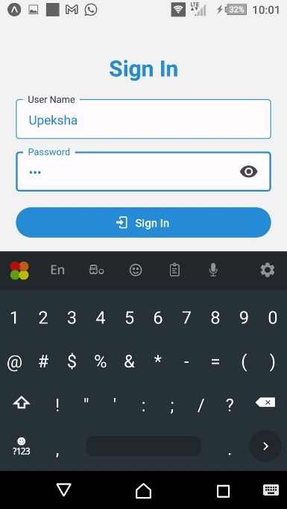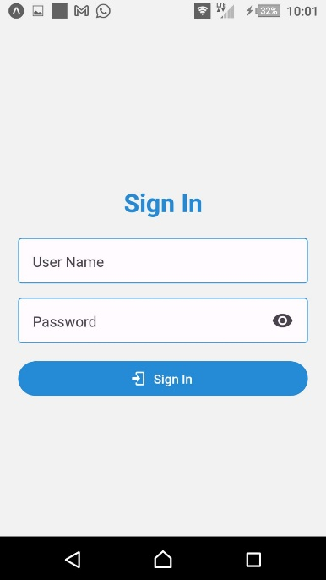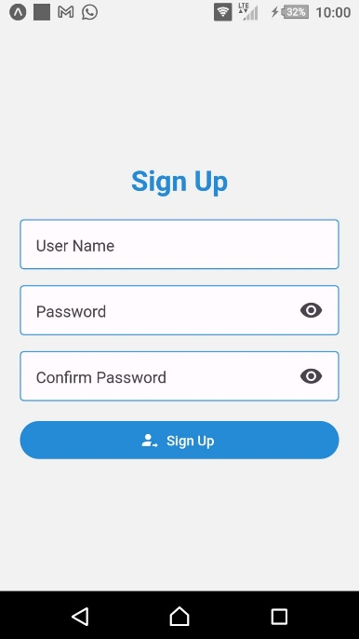

When considering the buying process, first click on the vehicle and can see the details of vehicle. And when click the buy button the ownership is transferred. Payments are done by Matic cryptocurrency.

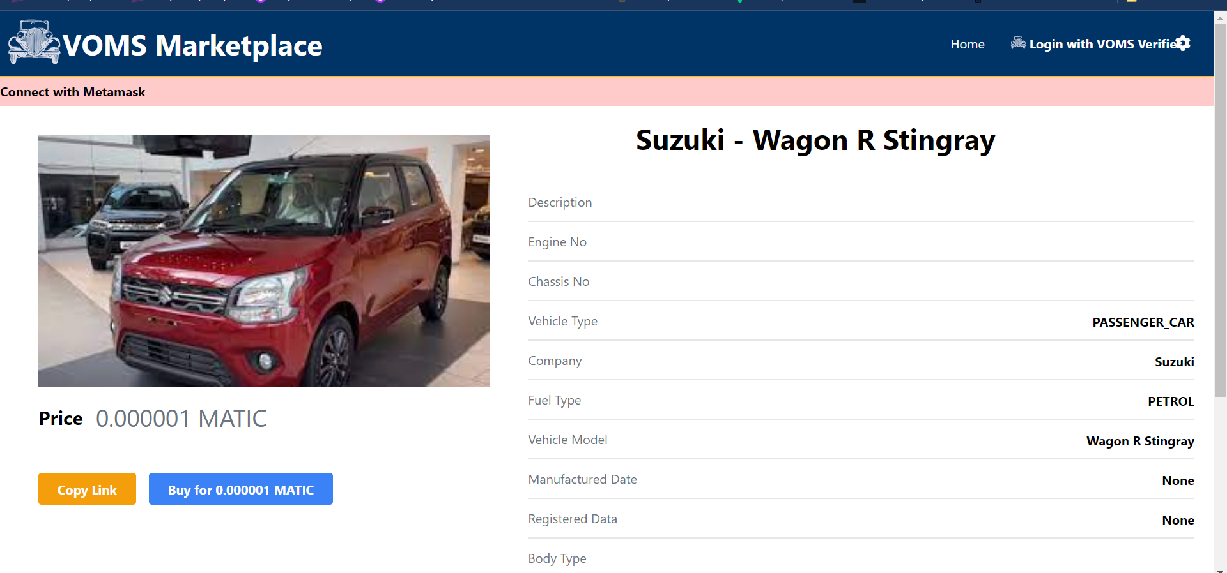

Figure ‑ More Details of Vehicle

When considering the selling process, First has to create NFT in marketplace. For that NFT Minter logs into the system. Then he has to fill the NFT requesting form. After submitting the form then the NFT is minted. Now the vehicle is shown in marketplace.

Figure ‑ Minting Officer Login Page

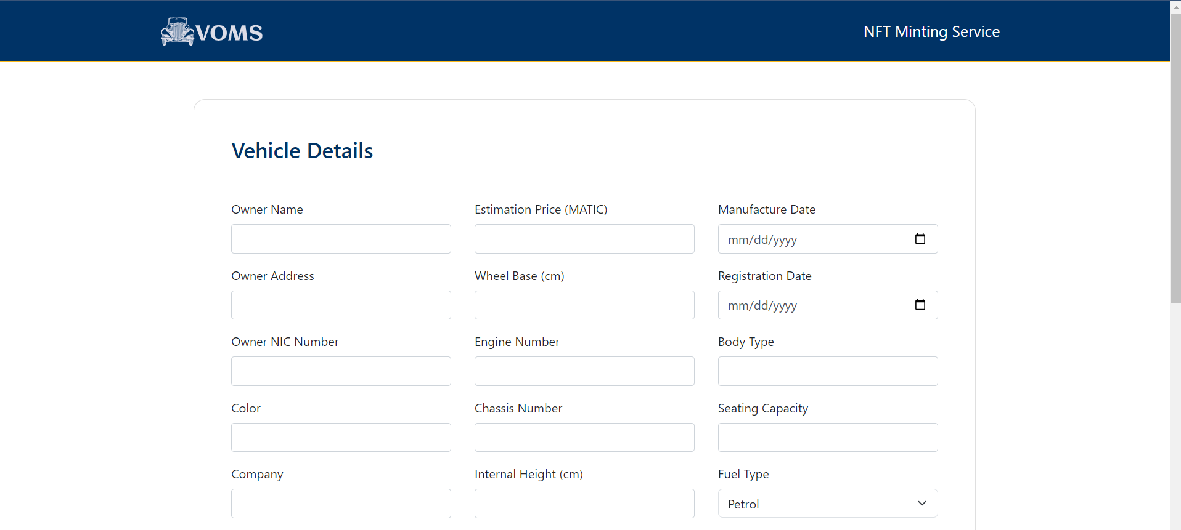

Figure ‑ NFT Minting Form

Figure ‑ NFT Minting Form Cont.

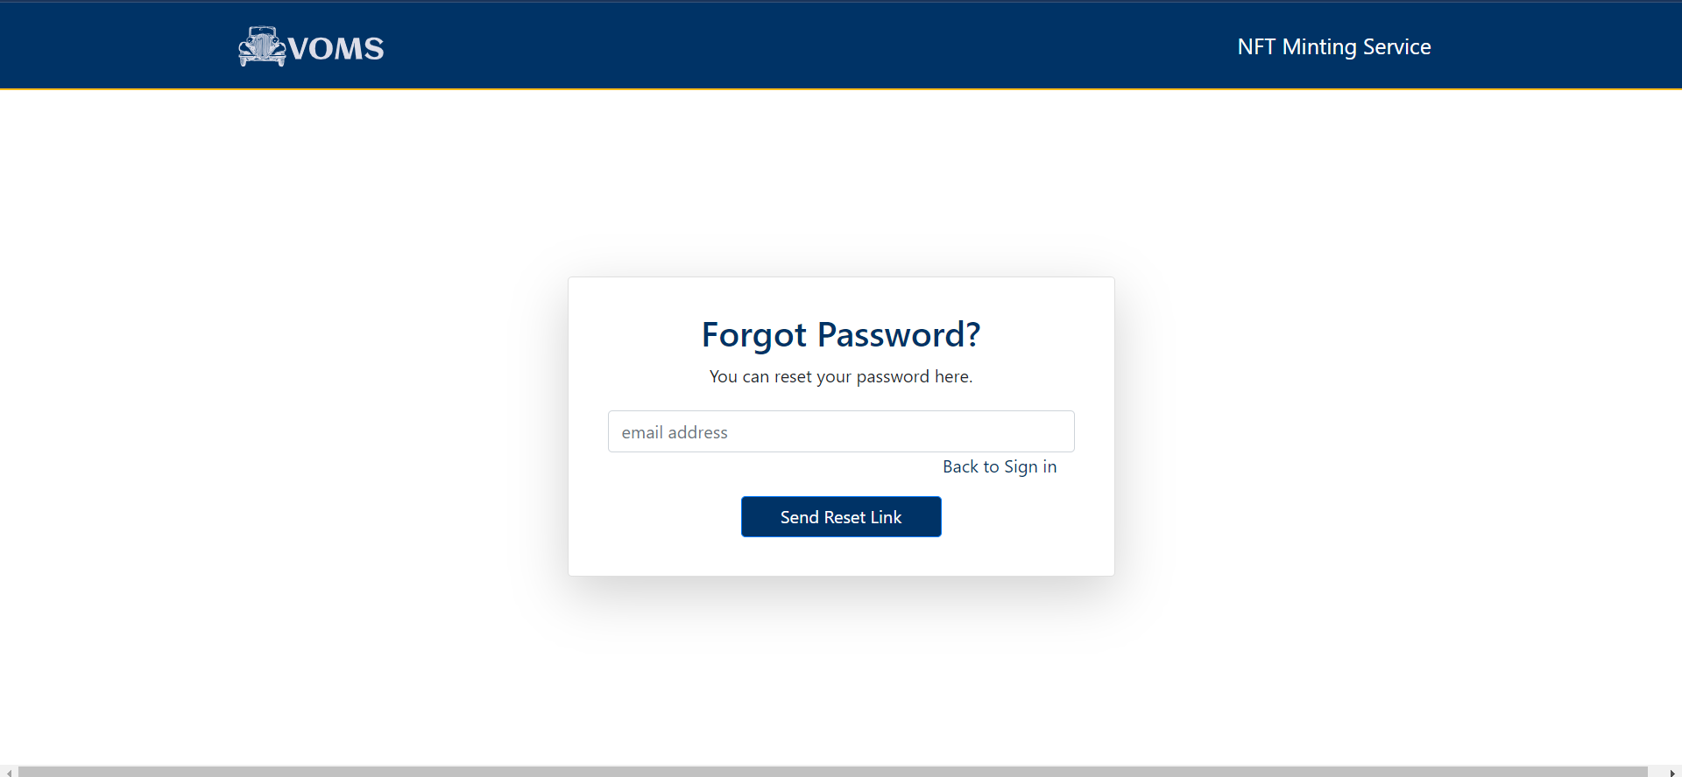

Figure ‑ Forgot Password Page

Able to show the status whether sell or not.

## Summary

In this chapter there have been already outlined the strategies that have followed for implementing modules. This application has divided into five parts like SSI Issuer, SSI Verifier, Mobile SSI wallet, NFT Minter, and NFT Marketplace. In the next chapter will discuss the evaluation and testing of the solution and how the solution differs from other solutions in the market, further developments, and implementation.

# Evaluation

## Introduction

In the previous chapter, the implementation of the proposed system up to now was discussed. Throughout this chapter, the evaluation and testing of solution, how the solution differs from other solutions in the market, further developments and implementation are discussed.

## Evaluation and Testing

In this chapter, a discussion will be held regarding how our solution differs from other products in the market.

## How Our Solution Differs from Other Solutions

The projects that discussed in chapter 2 were implemented slightly similarly to the blockchain-based vehicle registration and ownership management system. Therefore, there are some differences between similar projects and proposed project. In those projects, they just save their data in the blockchain rather than minting an NFT. There is no standard in those projects, and it is just a custom smart contract. However, the ERC 721 Standard NFT is implemented in the proposed project. The specialty of this standard is that these NFTs can be sold in any NFT marketplace. The difference between the section 2.3 project, Sandbox with proposed project is that the proposed project deals with real physical assets (vehicles) while selling and buying virtual assets (land) in the Sandbox. When taking section 2.4 OpenSea project, its trade in intangible, digital goods, rather than deals in tangible, physical assets - specifically, vehicles in the proposed project. In summary, the proposed project is different from what was researched previously because it is more complex and secure than all those mentioned projects.

## Further Development

As a further development, a new cryptocurrency is expected to be introduced to facilitate transactions in the marketplace for buying and selling vehicles. Additionally, a verification process will be added, which will involve with the database maintained by the government with vehicle details parallel to the manual verification process. The system is expected to be created to give offers to specific customers as per the owner's preference.

## Summary

In this chapter, mainly the evaluation and the testing of the proposed project were discussed. Furthermore, other similar solutions and how they differ from proposed solutions were described here. Additionally, new additions for the proposed project were mentioned under further development.

### NFT Marketplace System

|  |  |  |  |
| --- | --- | --- | --- |
| Case | Inputs | Expected Results | Actual Results |
| Login | Click the login button | Show a popup | Show a popup |
| View more | Click View More button | Show all details of the vehicle | Show all details of the vehicle |
| My Assets | Click My assets | Show all vehicles of the user | Show all vehicles of the user |
| Mark the status |  |  |  |
| Mark to be sell button | Put the tick | Show in the home page | Show in the home page |
| Mark as sold button | Put the tick | Show the vehicle in the sold items | Show the vehicle in the sold items |
| Home Page | Click Home Page | Show the home page | Show the home page |
| Meta mask wallet | Click the meta mask wallet | show connected MetaMask address | Want to show connected MetaMask address |
| Buy the vehicle |  |  |  |
|  | Click buy button before login | Login before purchase | Login before purchase |
|  | Click buy button after login | Confirm box | Confirm box |

### SSI Issuer

|  |  |  |  |
| --- | --- | --- | --- |
| Case | Inputs | Expected Results | Actual Results |
| **Login** |  |  |  |
| Enter a wrong username | Correct Password Wrong Username | “Invalid email or password” message | “Invalid email or password” message |
| Enter a wrong password | Correct Username Wrong Password | “Invalid email or password” message | “Invalid email or password” message |
| **Submit SSI creation form** |  |  |  |
| Submit form without filling a required field | Not fill a required field | “Please fill out this field” | “Please fill out this field” |
| Submit form with filling all required fields | Fill all the required fields | Sent an email with more instructions to the provided email | Sent an email with more instructions to the provided email |
| **Verify email address** |  |  |  |
| Click the link for verify email address | Click the link for verify email address | Generate QR code and display | Generate QR code and display |

### SSI Verifier

|  |  |  |  |
| --- | --- | --- | --- |
| **Verify SSI** | Expired SSI | Fail Verification | Fail Verification |
|  | Invalid SSI | Fail Verification | Fail Verification |
|  | Valid SSI | Verification Successful | Verification Successful |

### SSI Wallet

|  |  |  |  |
| --- | --- | --- | --- |
| Case | Inputs | Expected Results | Actual Results |
| Sign up  Sign in | Username, Password  Username and Password | Navigate to the Sign in Page  Navigate to the Home page | Navigate to the Sign in Page  Navigate to the Home page |
| Home | Click hamburger and Go to Home button | Shows a QR code scanner button | Shows a QR code scanner button |
| Credentials | Click on the credential button on navigation bar | Show all credentials of the user | Show all credentials of the user |
| Settings | Click on the settings button on navigation bar | Show the Settings of the application | Show the settings of the application |
| Connections | Click on the connections in the side navigation bar | Show all connections to the user | Show all connections to the user |

### NFT Minter

|  |  |  |  |
| --- | --- | --- | --- |
| Case | Inputs | Expected Output | Actual Output |
| **Login** |  |  |  |
| Enter a wrong Username | Correct Password Wrong Username | “Invalid email or password” message | “Invalid email or password” message |
| Enter a wrong password | Correct Username Wrong Password | “Invalid email or password” message | “Invalid email or password” message |
| **Forget Password** |  |  |  |
| Go to forgot password link and enter the email | Email | “Password reset link sent to your email account” message and password reset link sent to the email account | “Password reset link sent to your email account” message and password reset link sent to the email account |
| When entering a new password, enter a password which does not satisfy the requirements | 6 letters | “Password should be at least eight characters long” message | “Password should be at least eight characters long” message |
| NFT Minting Form | Not fill required fields | “Fill all required fields” | “Fill all required fields” |
| Create NFT | Click the button | “Successfully created your NFT” | “Successfully created your NFT” |

# Conclusion and Further Work

# In conclusion, the introduction of a blockchain-based vehicle registration and ownership management system presents a compelling solution to the security issues that arise during vehicle transfers and registrations. By leveraging the transparency and immutability of blockchain technology, this system offers several key advantages. Firstly, it enables efficient tracking of vehicle ownership and transfer, eliminating the need for cumbersome and error-prone centralized management solutions. Through the use of non-fungible tokens, vehicles can be uniquely represented on the blockchain, ensuring accurate and tamper-proof records. Secondly, the system provides a secure platform for storing and verifying essential documents such as titles and registration certificates. By leveraging self-sovereign identity, individuals can authenticate themselves and store their identity information in a mobile wallet, further enhancing the security of the process. Moreover, the system's marketplace feature streamlines the buying and selling of vehicles, facilitating transparent and trustworthy ownership transfers. With ownership changes recorded on the blockchain, the risk of fraudulent transactions or unauthorized alterations is significantly reduced. Overall, the application of blockchain technology in vehicle registration and ownership management offers a secure and efficient alternative to traditional methods. By leveraging the inherent features of blockchain, such as transparency, immutability, and decentralized control, this system has the potential to revolutionize the way vehicles are bought, sold, and transferred, ensuring a more reliable and fraud-resistant process.

# References

[1] S. M. H. Bamakan, N. Nezhadsistani, O. Bodaghi, and Q. Qu, “Patents and intellectual property assets as non-fungible tokens; key technologies and challenges,” *Sci Rep*, vol. 12, no. 1, Dec. 2022, doi: 10.1038/s41598-022-05920-6.

[2] “Difference between Centralized Database and Distributed Database - GeeksforGeeks.” https://www.geeksforgeeks.org/difference-between-centralized-database-and-distributed-database/ (accessed Dec. 24, 2022).

[3] “What is Blockchain Technology? - IBM Blockchain | IBM.” https://www.ibm.com/topics/what-is-blockchain (accessed Dec. 24, 2022).

[4] “Blockchain vs Database: Understanding The Difference.” https://101blockchains.com/blockchain-vs-database-the-difference/ (accessed Dec. 24, 2022).

[5] “Non-Fungible Tokens (NFTs) Explained | AWS Blockchain.” https://aws.amazon.com/blockchain/nfts-explained/ (accessed Dec. 24, 2022).

[6] “Mutability - Definition, Meaning & Synonyms | Vocabulary.com.” https://www.vocabulary.com/dictionary/mutability (accessed Dec. 24, 2022).

[7] Institute of Electrical and Electronics Engineers. Bangladesh Section, IEEE Region 10, and Institute of Electrical and Electronics Engineers, *2020 IEEE Region 10 Symposium (TENSYMP) : 5-7 June 2020, Dhaka, Bangladesh*.

[8] M. Dowling, “Fertile LAND: Pricing non-fungible tokens,” *Financ Res Lett*, vol. 44, p. 102096, Jan. 2022, doi: 10.1016/J.FRL.2021.102096.

[9] V. Nakavachara and K. Saengchote, “Does unit of account affect willingness to pay? Evidence from metaverse LAND transactions,” *Financ Res Lett*, vol. 49, p. 103089, Oct. 2022, doi: 10.1016/J.FRL.2022.103089.

[10] “OpenSea: Diving into the World of NFTs — AMT Lab @ CMU.” https://amt-lab.org/reviews/2022/1/opensea-diving-into-the-world-of-nfts (accessed Dec. 23, 2022).

[11] “Top 16 NFT Marketplaces for Creators to Sell Non-Fungible Tokens in 2023.” https://influencermarketinghub.com/nft-marketplace/#toc-0 (accessed Dec. 24, 2022).

[12] “OpenSea: Diving into the World of NFTs — AMT Lab @ CMU.” https://amt-lab.org/reviews/2022/1/opensea-diving-into-the-world-of-nfts (accessed Dec. 24, 2022).

[13] “What is Web 2.0 - Definition, Advantages and Features.” https://www.znetlive.com/blog/web-2-0/ (accessed Dec. 25, 2022).

[14] “ReactJS - Introduction.” https://www.tutorialspoint.com/reactjs/reactjs_introduction.htm (accessed Dec. 25, 2022).

[15] A. Carcangiu, G. Fenu, and L. D. Spano, “A design pattern for multimodal and multidevice user interfaces,” in *EICS 2016 - 8th ACM SIGCHI Symposium on Engineering Interactive Computing Systems*, Association for Computing Machinery, Inc, Jun. 2016, pp. 177–182. doi: 10.1145/2933242.2935876.

[16] “React Native · Learn once, write anywhere.” https://reactnative.dev/ (accessed Dec. 25, 2022).

[17] “What is Next.js? - Enonic.” https://enonic.com/blog/what-is-next-js (accessed Dec. 25, 2022).

[18] H. Gore *et al.*, “Django: Web Development Simple & Fast,” 2021. [Online]. Available: http://annalsofrscb.ro

[19] “PostgreSQL: The world’s most advanced open source database.” https://www.postgresql.org/ (accessed Jan. 01, 2023).

[20] “What is Web 3.0? - Definition from TechTarget.com.” https://www.techtarget.com/whatis/definition/Web-30 (accessed Dec. 25, 2022).

[21] “What is Blockchain Technology? - IBM Blockchain | IBM.” https://www.ibm.com/topics/what-is-blockchain (accessed Dec. 25, 2022).

[22] “AWS Marketplace: Hyperledger Indy (HVM).” https://aws.amazon.com/marketplace/pp/prodview-2ogkmzoksqkru (accessed Dec. 25, 2022).

[23] “Polygon blockchain explained: A beginner’s guide to MATIC.” https://cointelegraph.com/blockchain-for-beginners/polygon-blockchain-explained-a-beginners-guide-to-matic (accessed Dec. 25, 2022).

[24] “What Is IPFS?” https://beincrypto.com/learn/what-is-ipfs/ (accessed Dec. 25, 2022).

[25] “aries-cloudagent-python/DevReadMe.md at main · hyperledger/aries-cloudagent-python.” https://github.com/hyperledger/aries-cloudagent-python/blob/main/DevReadMe.md (accessed Dec. 25, 2022).

[26] “Hyperledger Indy Custom Network with Indy Node & Plenum(Protocol & Ledger) | by Ta-seen Junaid | Coinmonks | Medium.” https://medium.com/coinmonks/hyperledger-indy-custom-network-with-indy-node-plenum-protocol-ledger-85fd10eb5bf5 (accessed Dec. 25, 2022).

[27] “Demonstration of Hyperledger Aries Cloud Agent | by KC Tam | Medium.” https://kctheservant.medium.com/demonstration-of-hyperledger-aries-cloud-agent-6e476a5426b0 (accessed Jun. 09, 2023).

[28] “MetaMask Wallet Review 2022.” https://www.investopedia.com/metamask-cryptocurrency-wallet-review-5235562 (accessed Dec. 25, 2022).

[29] “What is Docker? | IBM.” https://www.ibm.com/topics/docker (accessed Dec. 26, 2022).

[30] “Overview | Docker Documentation.” https://docs.docker.com/compose/ (accessed Dec. 26, 2022).

## Appendix A - Individual Contribution

**204047J Dissanayake DMBM – NFT Minter**

As the leader of the team my responsibilities are to arrange meetings with mentors, supervisors, manage the project, arrange knowledge sharing sessions, manage the git repository and to share tasks among other team members correctly. As a team member I was assigned to do the NFT Minter module.

I could successfully arrange meetings with our supervisor in which we gained knowledge and resolved errors and mistakes. Moreover, I arranged knowledge sharing sessions and as a result every member will be able to implement a module fully functional with frontend and backend. While doing the project I and another member managed a git repository for our project and every member uploaded their module to the repository. Furthermore, I used Jira project management tool to manage the project. I contributed to the designing phase by drawing diagrams.

In the NFT minter module, Blockchain–Based Vehicle Registration and Ownership Management System, after issuing a Self-Sovereign Identity (SSI), we want to register their vehicle also. We used a Nonfungible Token (NFT) to represent the vehicle in our marketplace. To do that, we mint an NFT with all details of the vehicle and transfer ownership. This is a closed system. This system is used by only authorized persons in a particular company. When a vehicle is registered at first time the vehicle owner wants to go to that company to register his vehicle with all necessary details.

I have done the login function, NFT Minting form, Generating NFT function using Django, HTML, CSS, JavaScript, Bootstrap, Indy Blockchain.

**204074M Herath PAUD** - **Mobile SSI wallet**

I was assigned to develop the Mobile SSI wallet module. I contributed to the designing phase by drawing use case diagram, class diagram, sequence diagram, activity diagram and ER diagram.

The SSI (Self-Sovereign Identity) which is issued for users through the SSI issuer system. This mobile application is used by normal citizens and especially our target audience is the ones who use the NFT marketplace. When any third-party person needs to check the identity of any person that third-party person can check that person's SSI (which is stored in this mobile application) and identify that person.

In the SSI Mobile Wallet module, after entering the password then the general user can login to the Mobile SSI Wallet. Then the home page of the wallet will be displayed. To make a connection with a SSI Issuer first have to scan the QR Code issued by the SSI Issuer. After the connection is established, the SSI issuer will send the relevant SSI to this mobile wallet through connection and that sent credential will be saved.

**204087F Jayathilaka PHP -NFT Marketplace**

I was assigned to develop the NFT marketplace. I contributed to the designing phase by drawing use case diagram, class diagram, sequence diagram, activity diagram and ER diagram.

In our Blockchain – Based Vehicle Registration and Ownership Management System, we have a platform to sell and buy vehicles. This is an open system for any user. Anyone can access the system through their Self Sovereign Identity (SSI).

In the NFT marketplace module, upon logging in with their SSI credentials, the general user is able to view a selection of vehicles available for sale on the home page of NFT Marketplace. In the home page there can be seen each vehicle as a card with an image of that vehicle and few details. After clicking on any card, the general user is directed to a page which can be seen all the details (past owners, price, vehicle technical details, vehicle number, etc.) related to that vehicle. There is a separate tab to view the NFTs which belong to that user. There is a separate button to move to the selling pages. And the seller can fill in a few data fields and make a particular NFT available for selling. And if any buyer needs to buy a particular vehicle, that person can click on the vehicle card that he wants to buy. And after clicking there is an option to buy that vehicle and after using that option the buyer can do the transaction using cryptocurrency. And then the transaction happens with the aid of the MetaMask wallet and the ownership of the NFT is transferred to the new owner. Also, while doing the project, I and other member managed a git repository for our project and every member uploaded their module to the repository.

**204150T Pathirana SPSN - SSI Verifier**

I was assigned to develop the Mobile SSI verifier module in Blockchain – Based Vehicle Registration and Ownership Management System. I contributed to the designing phase by drawing use case diagram, class diagram, sequence diagram, activity diagram and ER diagram.

The SSI verifier verifies the SSI which is sent by the NFT minter, NFT marketplace and other necessary parties. It is verified by using the Indy blockchain and sending a message as response confirming the validation of the details. There are two verifying processes related to our project. One is SSI verifier module will be used in the login to the NFT Marketplace. The other verifying approach is that the third-party person (such as police officers) can use this SSI Verifier to check whether the real identity of a general person. This module is beneficial to find the real identity of a person in day-to-day life normal activities.

In the SSI verifier module, there is a QR code to scan to the users. In addition to, there are three features like link to open in a trusted wallet, invitation link and copy invitation link.

I have done the SSI verification function using Django, HTML, CSS, JavaScript, Bootstrap.

**204179N Rathnayaka AMDB -SSI Issuer**

In our project Blockchain Based Vehicle Registration and Ownership Management System I was assigned to develop the SSI Issuer module. I contributed to the designing phase by drawing use case diagram, class diagram, sequence diagram, activity diagram, ER diagram.

In the Blockchain Based Vehicle Registration and Ownership Management System, we are using SSI- Self Sovereign Identity which is an ID to identify the vehicle owner which is a digitally verifiable ID. We can use this ID to log in and log out of the digital NFT marketplace (vehicle). The data for the SSI creation form comes from the general user and that data is provided via a form filled by the general user manually. This is a closed system that can be only accessed by the SSI Issuing officer.

In the SSI Issuer module, first the SSI issuing officer submits the already provided username and the password then he or she can log in to the system. After login he or she directs into an SSI generating details form. Then that form will be filled out by the SSI issuing officer and provided as input for the system. As a result of that form submission, the SSI Issuer module will generate an SSI. Then a verifiable email will be sent to the relevant email address which is provided in the SSI requesting form. In that email, there is a link to verify the email provided. After verifying the email, a QR code and a link will be displayed. After scanning the QR code using the SSI Mobile Wallet or clicking the link the general user can make a connection through the system with the SSI Mobile Wallet. According to the generated connection with the SSI Mobile Wallet, this SSI Issuer module will send the SSI which is generated related to the submitted data of that general user.

I have done the login function, SSI requesting form, generating QR code function, email verification function using Django, HTML, CSS, JavaScript, Bootstrap.

## Appendix B

Figure ‑ Implementation Backend 204047J

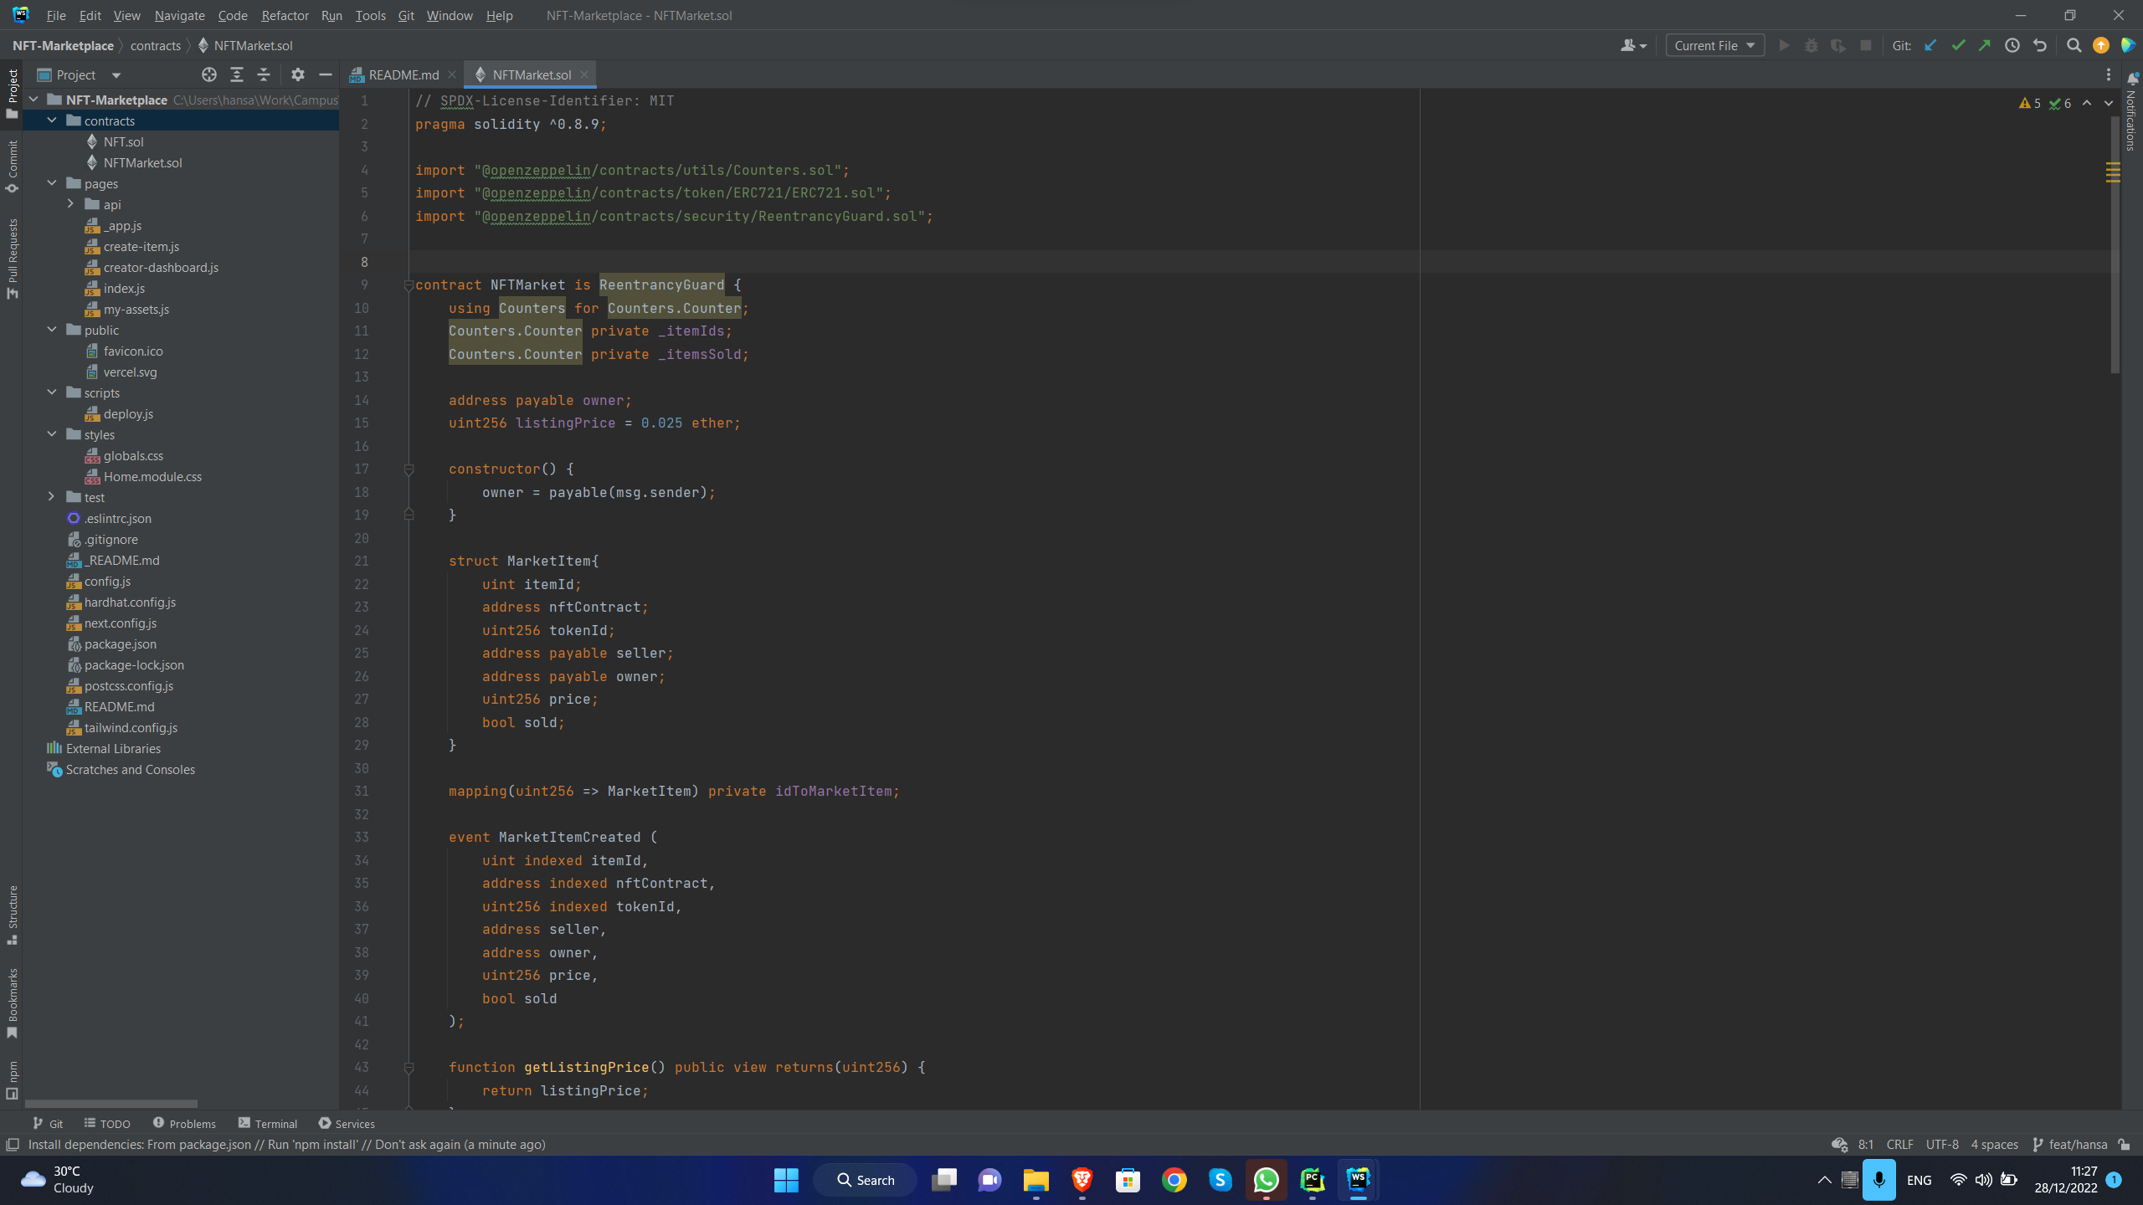

Figure ‑ Implementation Backend 204087F

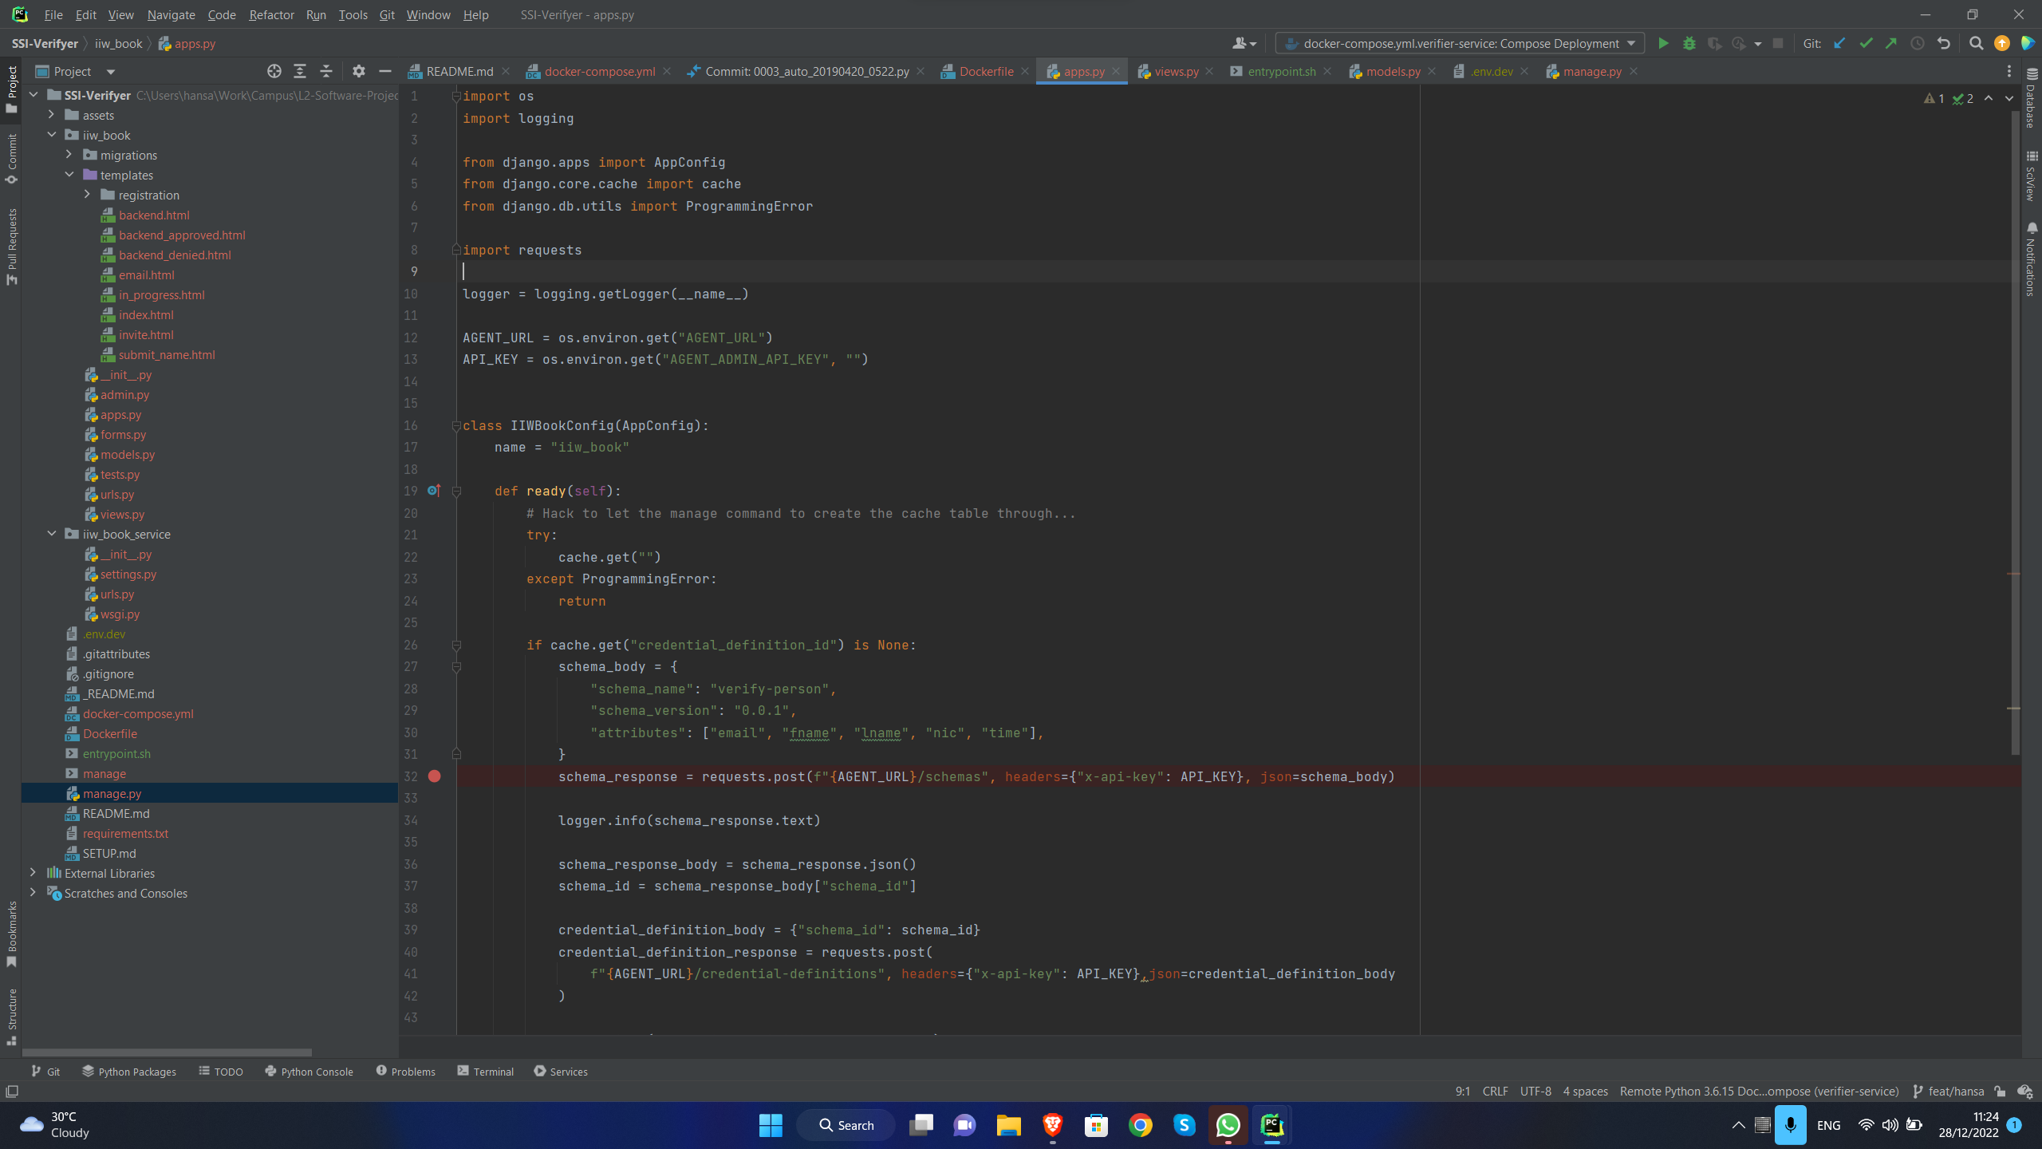

Figure ‑ Implementation Backend 204150T

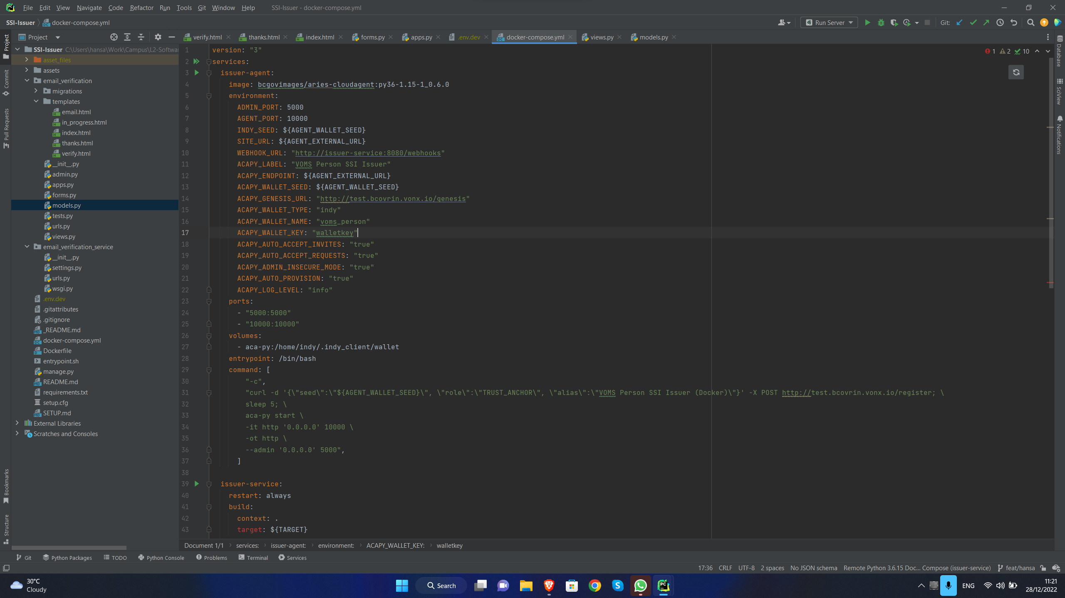

Figure ‑ Implementation Backend 204179N

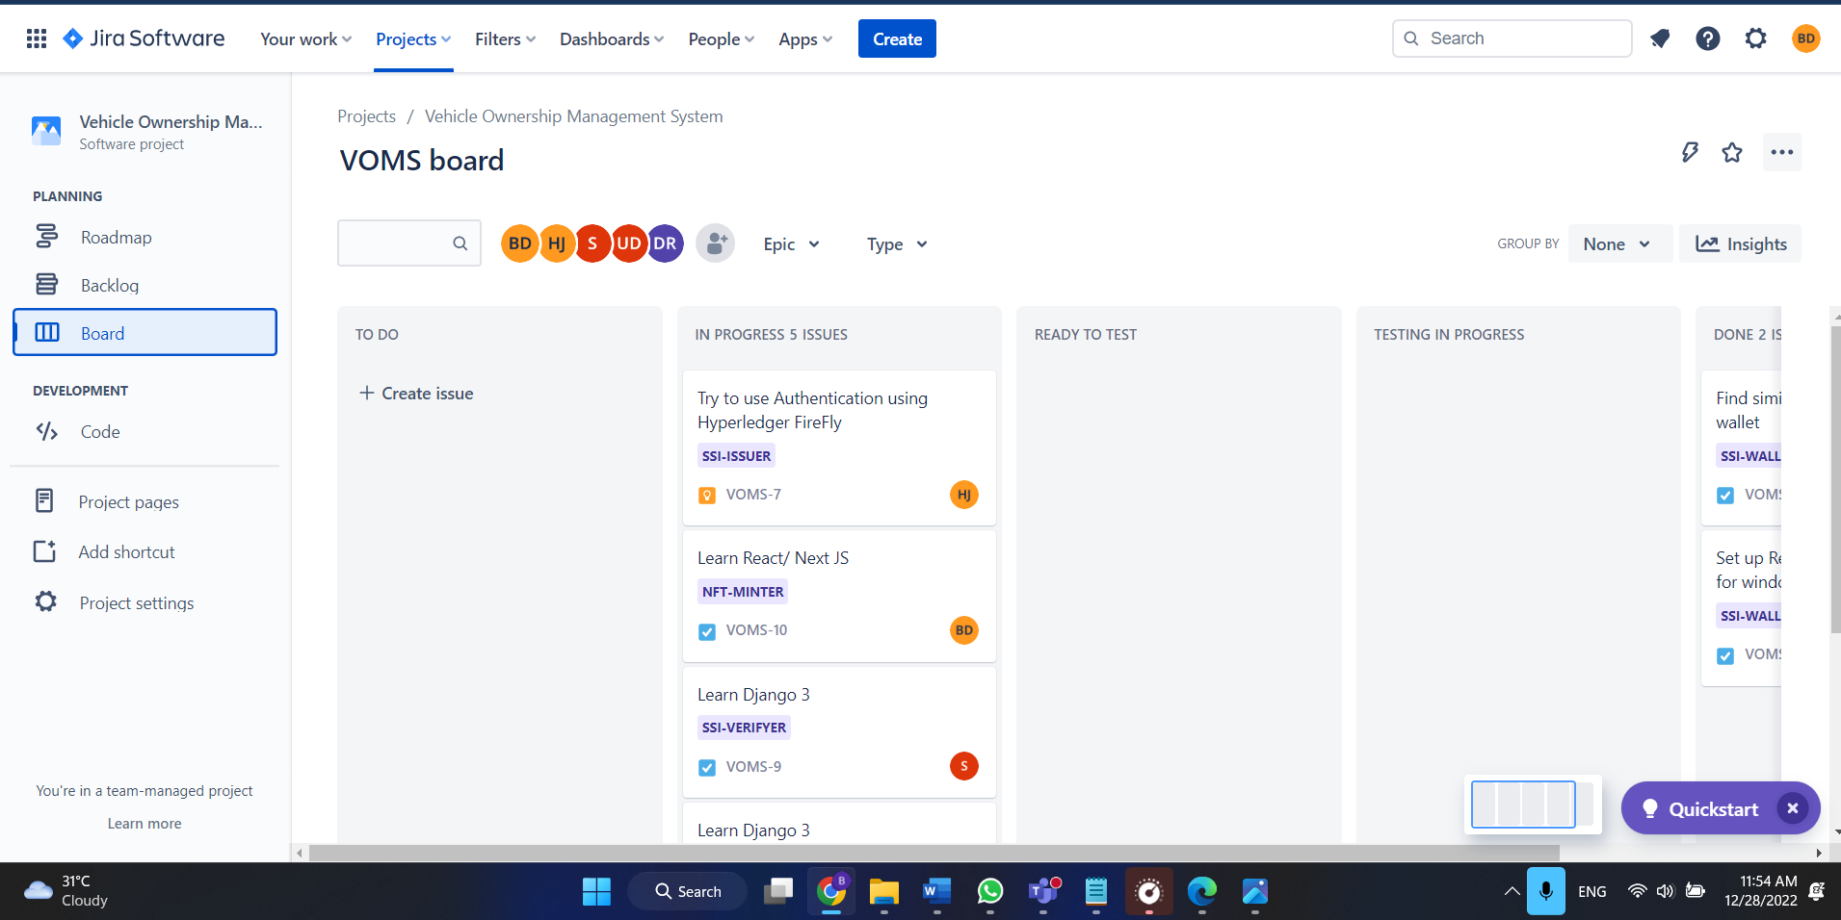

Figure ‑ Jira as Project Management tool

## Appendix C – Plan of Action

|  |  |  |  |  |  |  |  |  |  |  |  |  |
| --- | --- | --- | --- | --- | --- | --- | --- | --- | --- | --- | --- | --- |
|  | **2022** | | | | **2023** | | | | | | | |
|  | **Sep** | **Oct** | **Nov** | **Dec** | **Jan** | **Feb** | **Mar** | **Apr** | **May** | **Jun** | **July** | **Aug** |
| Study about blockchain, React, Django |  |  |  |  |  |  |  |  |  |  |  |  |
| Requirements gathering and analysis |  |  |  |  |  |  |  |  |  |  |  |  |
| System Develop |  |  |  |  |  |  |  |  |  |  |  |  |
| Implement web application |  |  |  |  |  |  |  |  |  |  |  |  |
| Implement mobile application |  |  |  |  |  |  |  |  |  |  |  |  |
| System Testing |  |  |  |  |  |  |  |  |  |  |  |  |
| Finalize the project |  |  |  |  |  |  |  |  |  |  |  |  |

## Appendix D – User Stories

* As a general user, I want to give my data to the SSI issuing officer via a hard copy, so that I can request an SSI.
* As a general user, I want a SSI, so that I can log into the NFT marketplace.
* As a SSI issuing officer, I want login credentials, so that system will prevent unauthorized access.
* As a SSI issuing officer, I want to validate data, so that the system can avoid misuse of SSI.
* As a general user, I want to verify email, so that I will prevent from entering invalid email.
* As a vehicle owner, I want an NFT, so that I can sell my vehicle in the NFT marketplace.
* As an NFT minting officer, I want login credentials, so that system will prevent unauthorized access.
* As a buyer, I want to select an NFT, so that I can buy a vehicle.

## Appendix E – SRS